**SYSTEM DEVELOPMENT PROJECT**

**ON**

#### MyLaundry

**(Web Based Application)**

**IN PARTIAL FULFILMENT OF**

**BACHELOR’S DEGREE IN COMPUTER APPLICATIONS (B.C.A.) GUJARAT UNIVERSITY (2020-2021)**

**SUBMITTED BY**

**101 Sirsolkar Abhishek Subhashbhai**

**105 Solanki Rohitkumar Manubhai**

**113 Thakkar Karan Dilipkumar**

**SOM-LALIT INSTITUTE OF COMPUTER APPLICATIONS**

**(*Affiliated to GujaratUniversity, BCA Programme)***

**SLIMS Campus, Nr. Xavier’s corner, University Road, Navrangpura,**

**Ahmedabad – 380 009.**

**SOM-LALIT INSTITUTE OF COMPUTER APPLICATIONS**

**(*Affiliated to the Gujarat University)***

**SLIMS Campus, Nr. St. Xavier’s Corner, University Road, Navrangpura,**

**Ahmedabad – 380009.**

**S L I C A**

**Phone: 26303301/2/3 Email:** [**info@somlalit.org**](mailto:info@somlalit.org) **Website:** [**www.somlalit.org**](http://www.somlalit.org/)

**CERTIFICATE**

This is to certify that SOFTWARE DEVELOPMENT PROJECT

**“MyLaundry**” isdeveloped and submitted to GujaratUniversity by

**Mr. Sirsolkar Abhishek Subhashbhai**

**Mr. Solanki Rohitkumar Manubhai**

**Mr. Thakkar Karan Dilipkumar**

In partial fulfillment of the requirement for the award of the

**“Bachelor’s Degree in Computer Applications (B.C.A.)”**

in the year 2020-2021.

This is the original work and carried out under guidance and supervision.

We further certify that to the best of our knowledge and belief the matter

presented in this project report is bonafied.

**Nameofguide I/cDirector**

*Prof. Khyati Shah Mr. K. J.Patel*



**HASMUKH LAUNDRY SERVICES**

**ADDRESS :- SIR LAKHAJIRAJ ROAD ,**

**SANGANVACHOWK , TRIKON BAG , RAJKOT –360007**

**CERTIFICATE**

This is to certify that

**Mr. Sirsolkar Abhishek Shubhash ,**

**Mr. Solanki RohitKumar ManuBhai** and

**Mr. Thakkar Karan DilipBhai**

Student of Som-Lalit Institute of Computer Application (SLICA),

Ahmedabad, has done and successfully completed their Software

Development Project Phase : II

**“MYLAUNDRY”**

In our organization during 15th Jun 2020 to 20th Nov 2021.

Their work and conduct during the project was found very good.

We wish them all the best in their future endeavors.

**Date :** **Organization Seal** **Authorized Signatory**

 **mylaundrybusiness@gmail.com**

 **884905951**

# Acknowledgement

We extend our sincere thanks to our college “Som-Lalit Institute Of Computer Application (SLICA)”, our respected principal Mr. K. J. Patel, our respected faculties for giving us the golden opportunity to work on the project of “MYLAUNDRY” by providing us their precious time, deep and valuable knowledge to make project – asuccess.

We extend our warm thanks to our project guide Prof. Khyati Shah for her guidance and constant encouragement throughout the semester by providing their valuable time, advices for various problems whenever we needed for deciding the objectives of our report.

We extend our grateful thanks to Mr. Dilipbhai Thakkar, the owner of “Hashmukh Laundry Services”, for providing us the opportunity to work for their software creation of their Laundry Shop.

We express our thanks to our Parents, classmates and other external sources who helped us directly or indirectly.

Mr. Sirsolkar Abhishek S.

Mr. Solanki Rohit M.

Mr. Thakkar Karan D.

**INDEX**

**SR.NO. CONTENTS**

1. Introduction ………………………………………………………...
2. Company Profile …………………………………………………...
3. Admin Panel ………………………………………………………..
4. Customer Panel ……………………………………………………..
5. Reports ………………………………………………………………

­­­

# **Introduction**

* MyLaundry will be website that helps customer to select packages(yearly , monthly) or service (e.g. Wash , iron and dry cleaning) and it will also provide pickup and delivery from customer home.
* It will also help admin manage customer details, order details and keep records of customers , services and package online.

# **Company Profile**

|  |  |
| --- | --- |
| Company Name : | Hashmukh Laundry Services |
| Address : | Sir Lakhajiraj Road, Sanganva Chowk, Trikon Baag, Rajkot-360007 |
| Contact No. : | +91 8849059151 |
| Email Id : | [mylaundrybusiness@gmail.com](mailto:mylaundrybusiness@gmail.com) |
|  |  |

# **Some Generalized Modules**

# **Login**

# **Forgot Password**

# **User can’t login directly without Username and password.**

# 

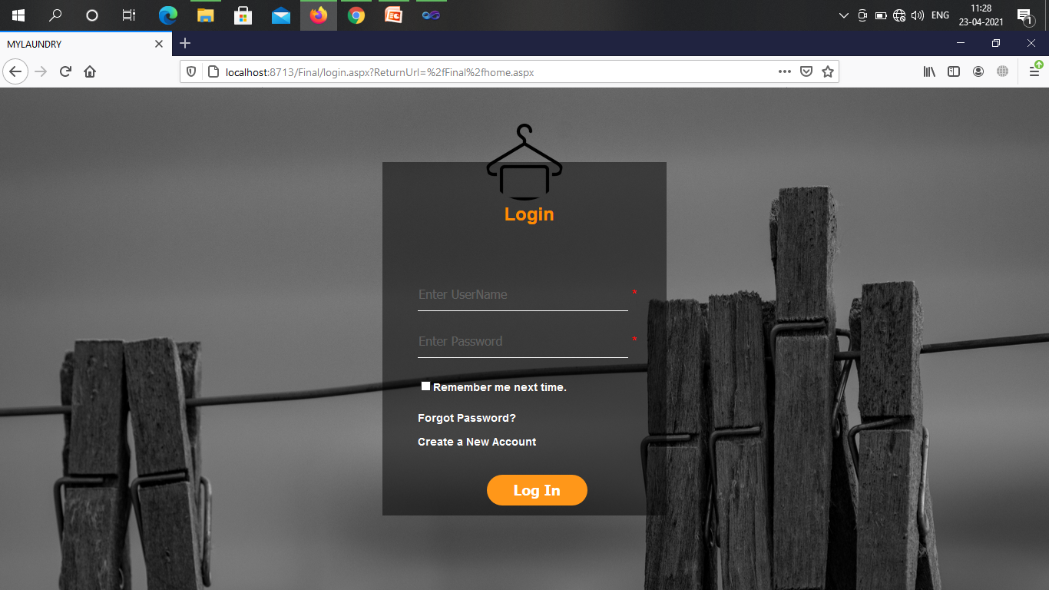

* **Entering Username and not password.**

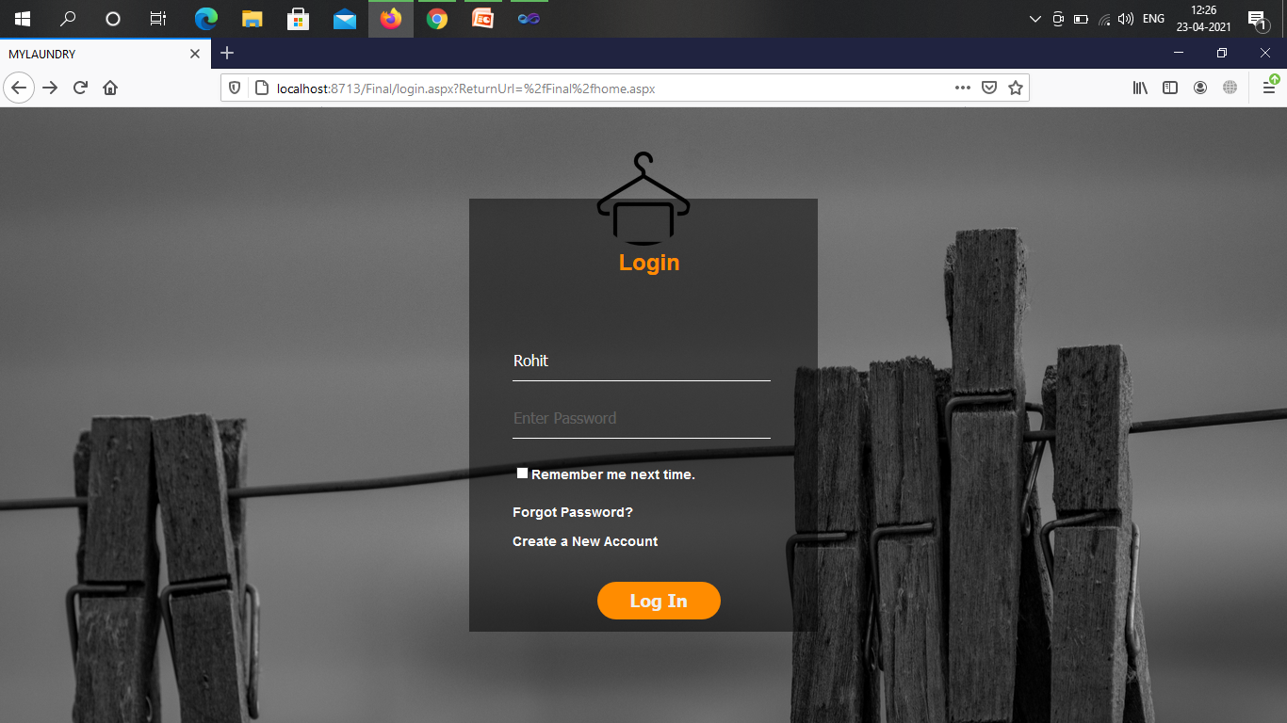

* **System notifies this is mandatory field.**

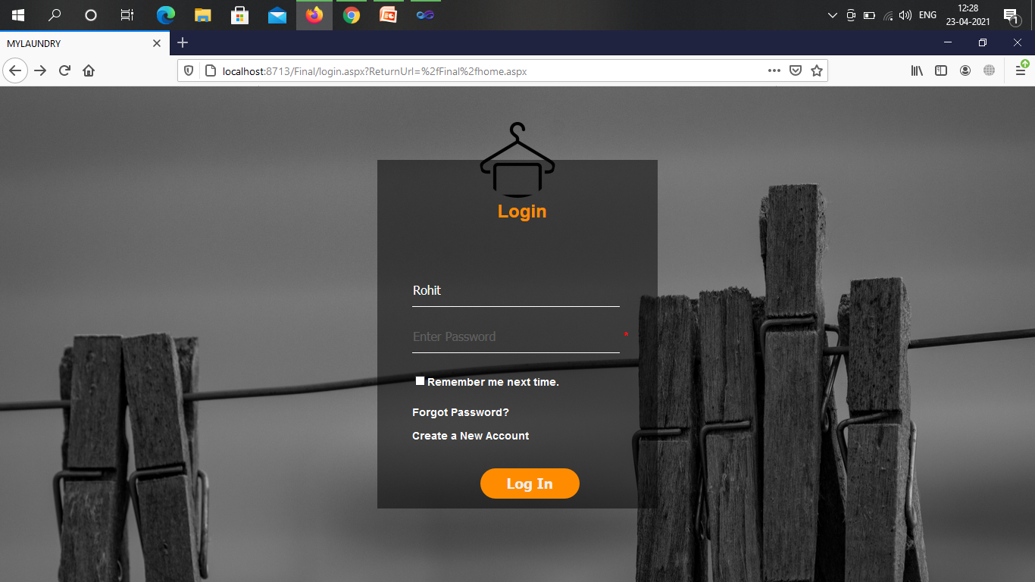

* **With Username and wrong password.**

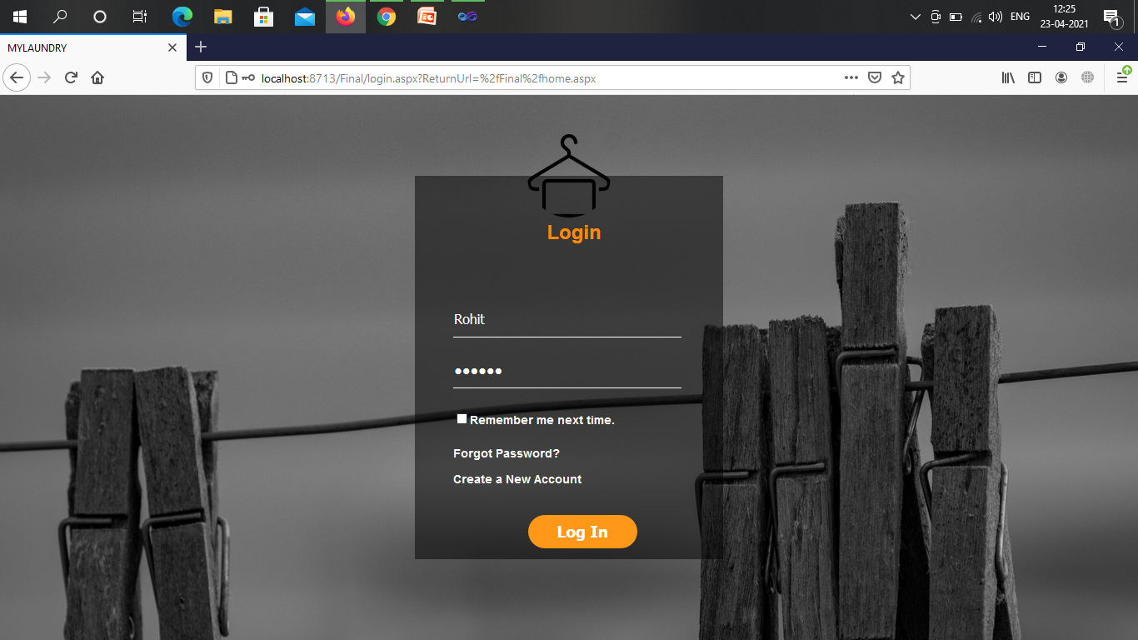

* **Error shown**

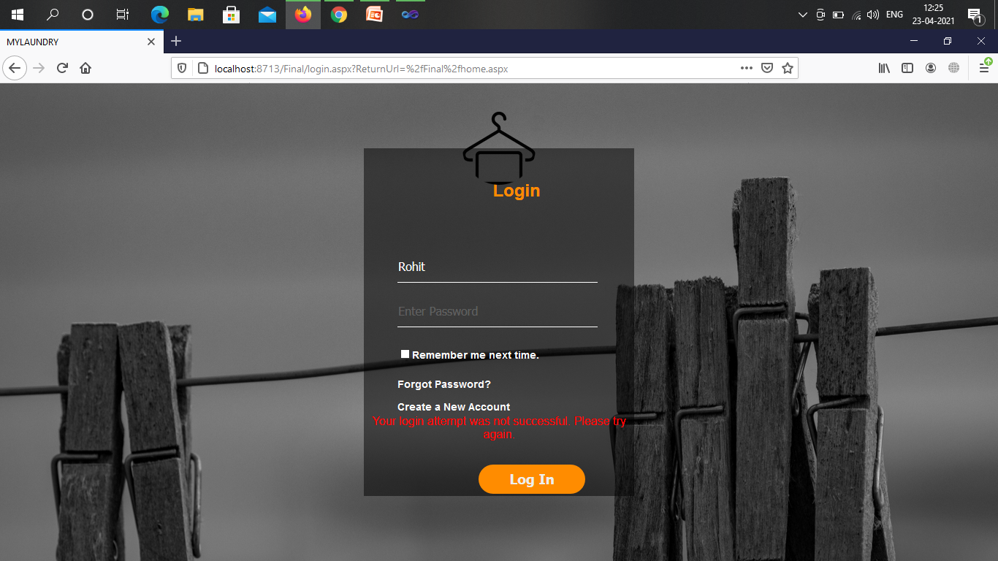

* **With Correct Username and password.**

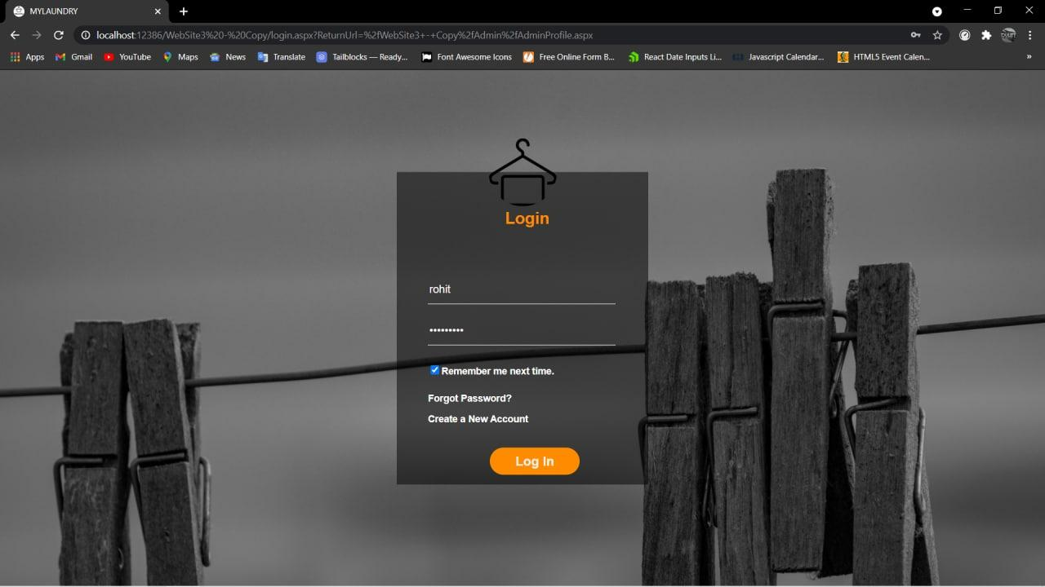

* **If login user is admin.**

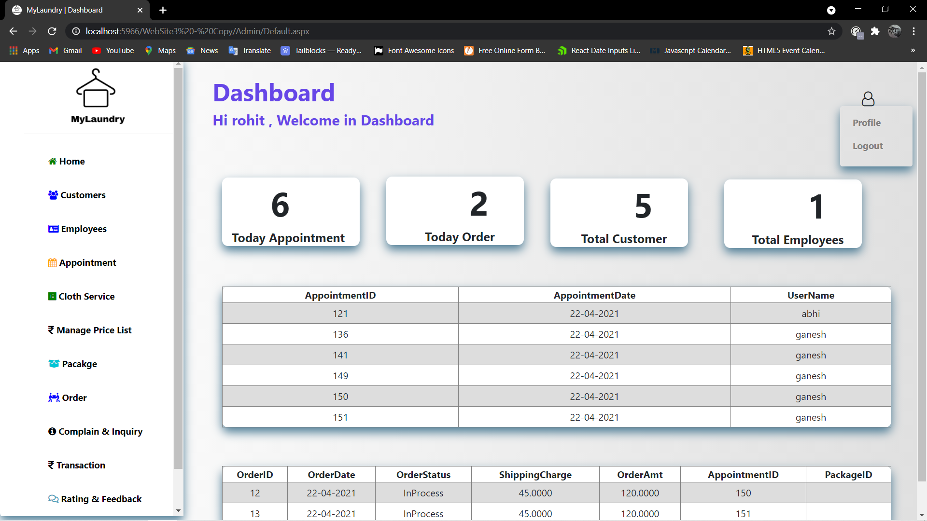

* **If login user is customer .**

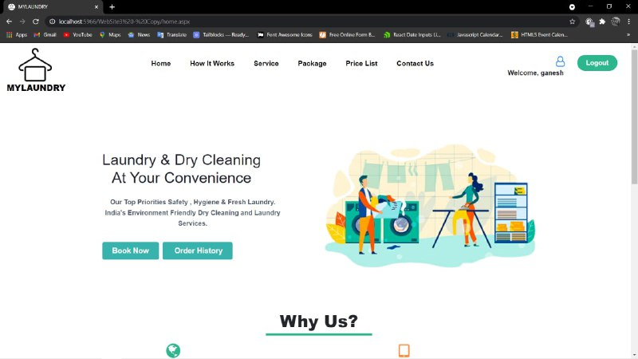

* **When user forgot there password.**

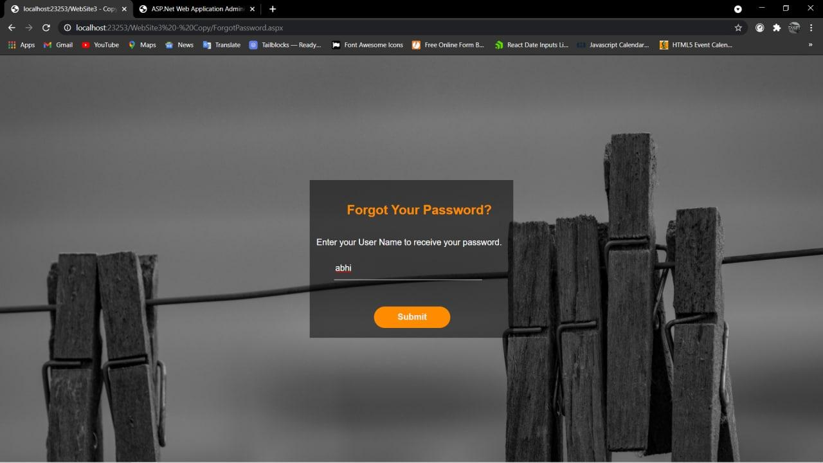

* **When user enter wrong security answer.**

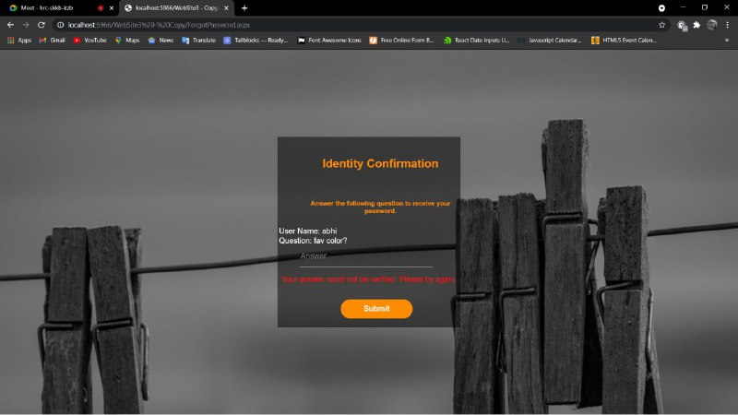

* **When user enter correct security answer.**

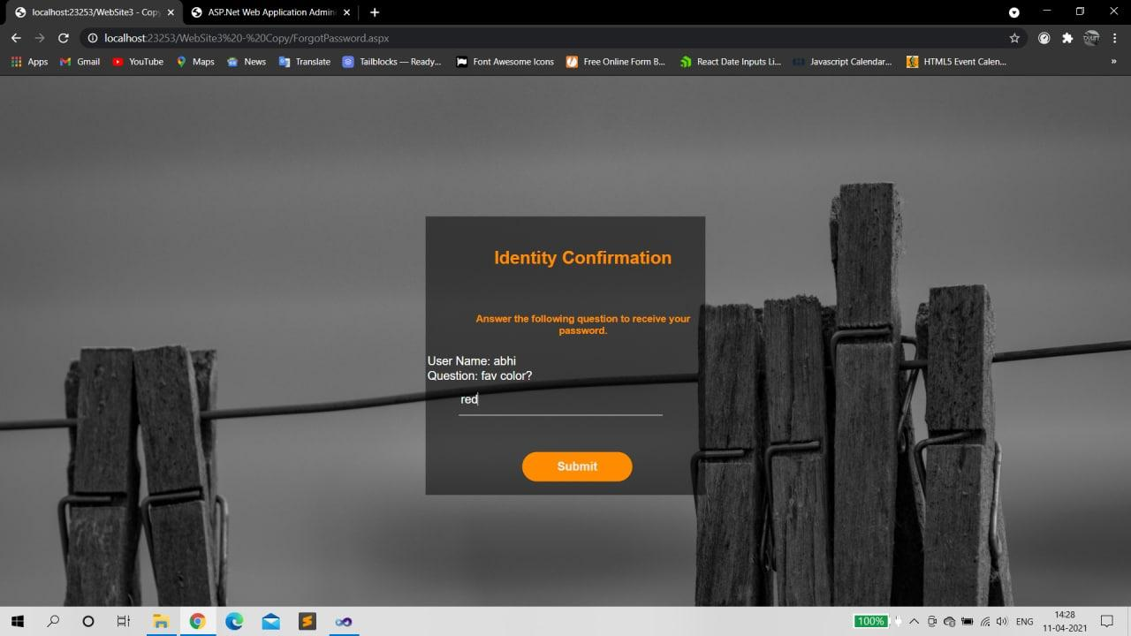

* **Password received on email.**

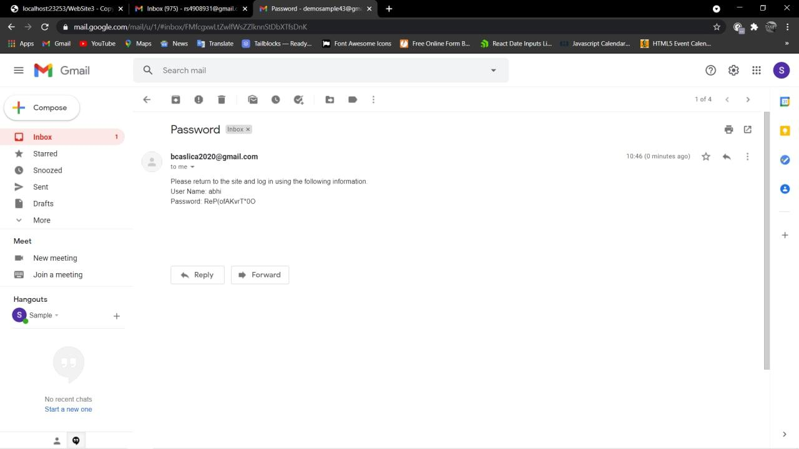

* **Registration Form**

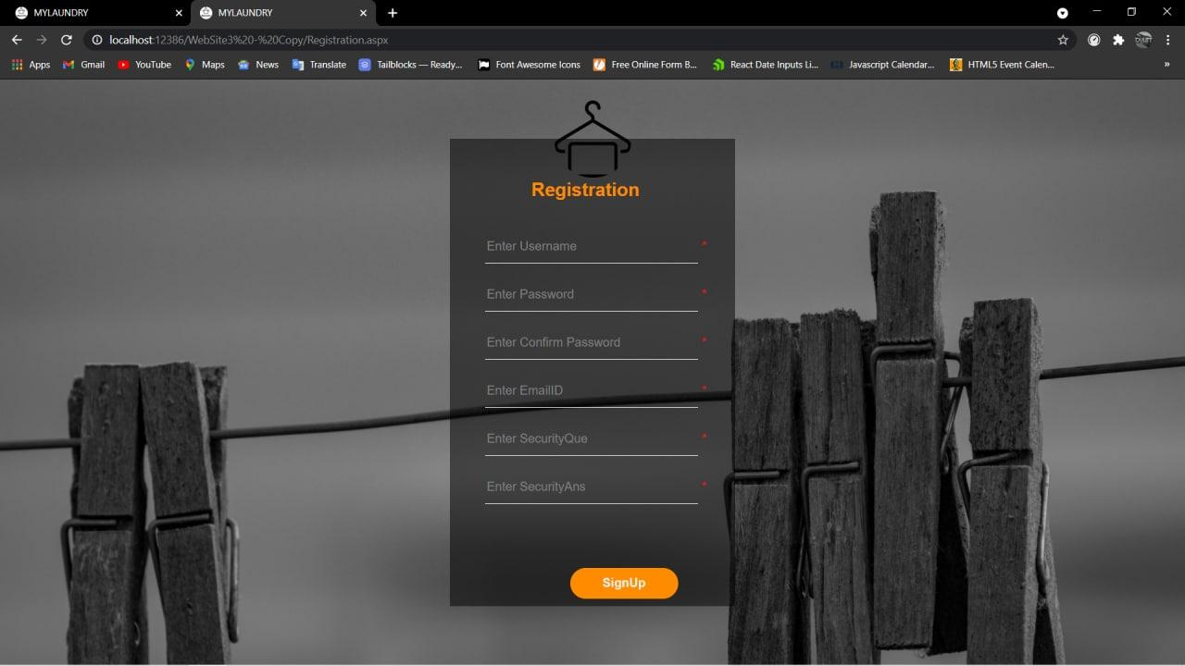

* **If username already exists then error is shown.**

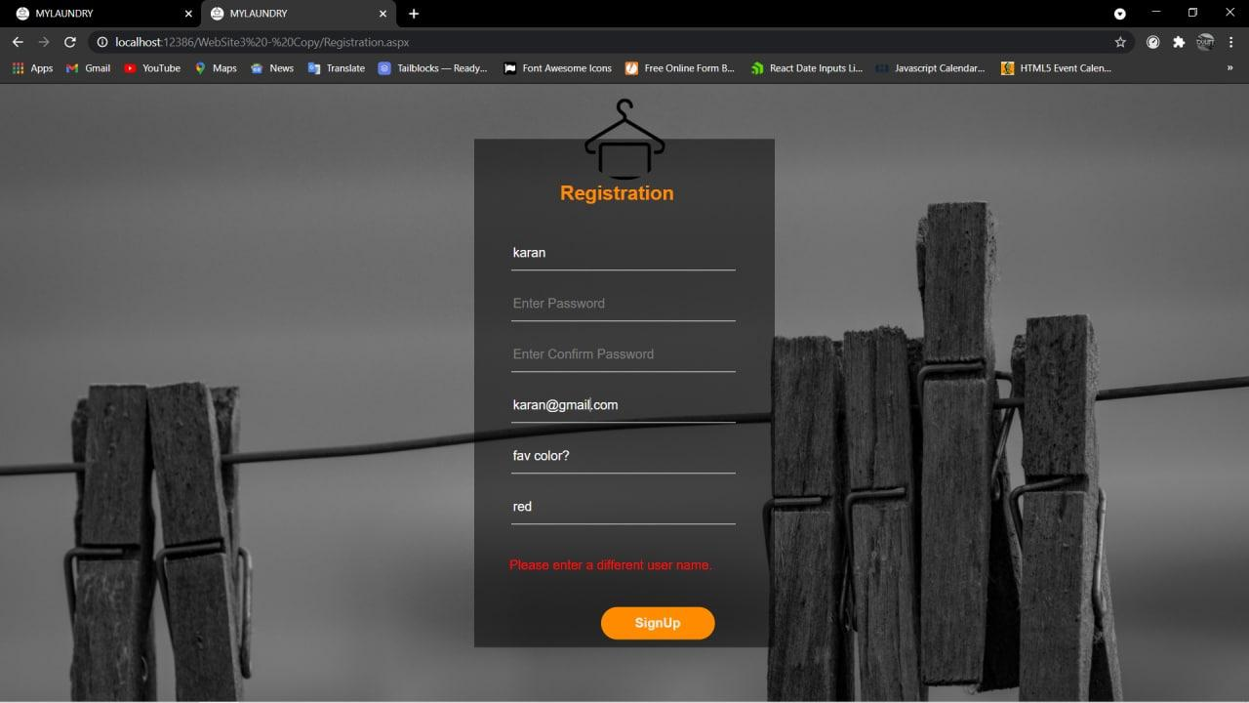

* **If Password and Confirm password don't match then error is shown.**

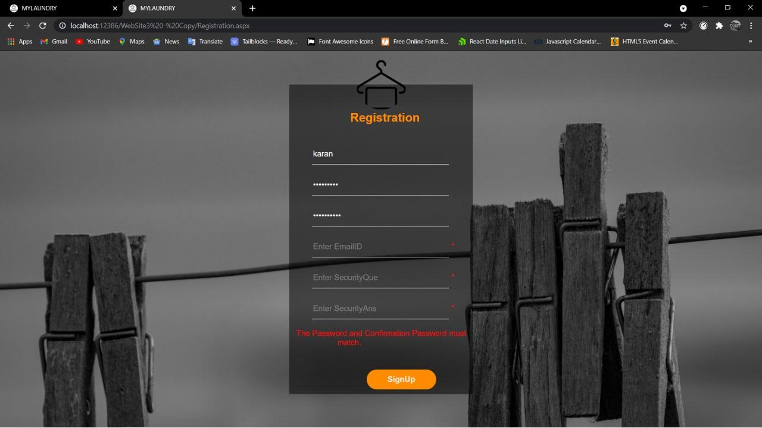

* **If Email-id is not in correct format then again shown Error.**

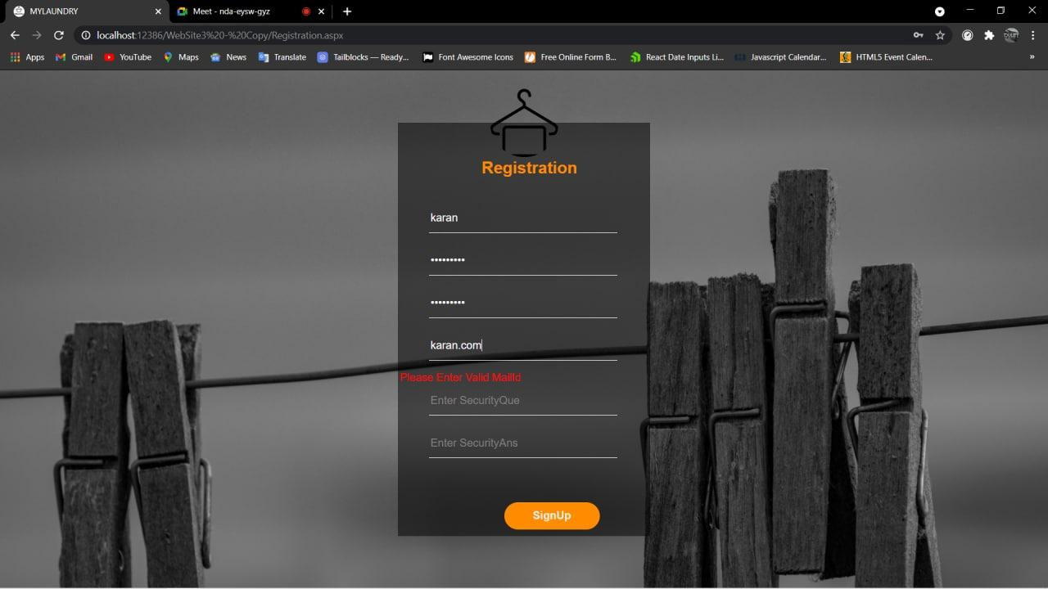

* **When user clicks on Signup button then shown User Profile Form.**

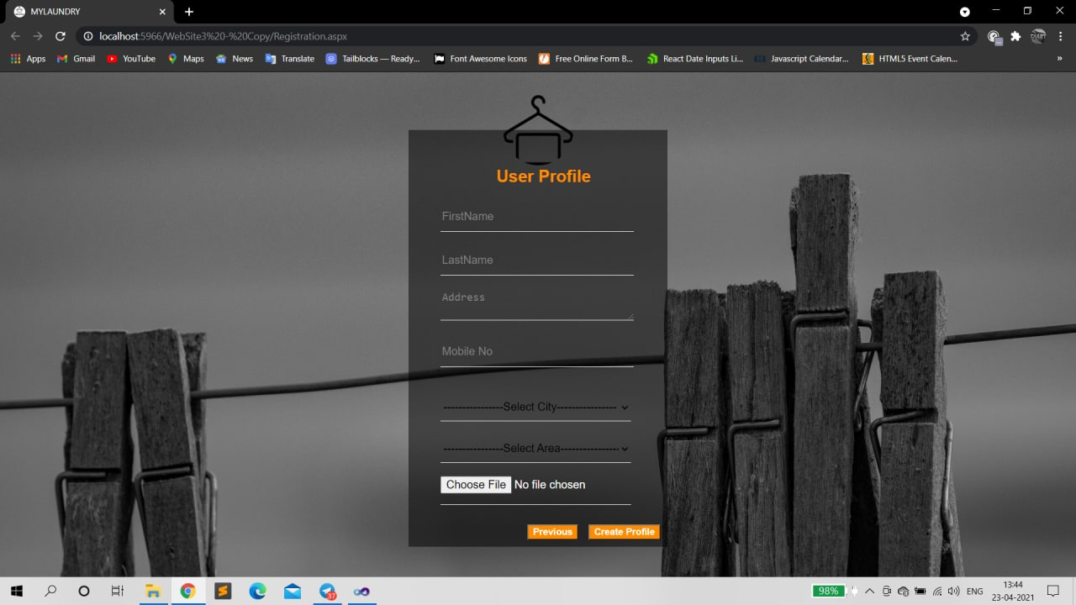

* **File upload control shown when User Uploads their Profile Picture.**

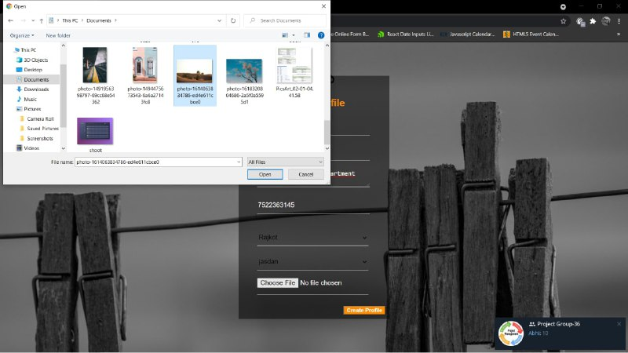

* **User account created successfully.**

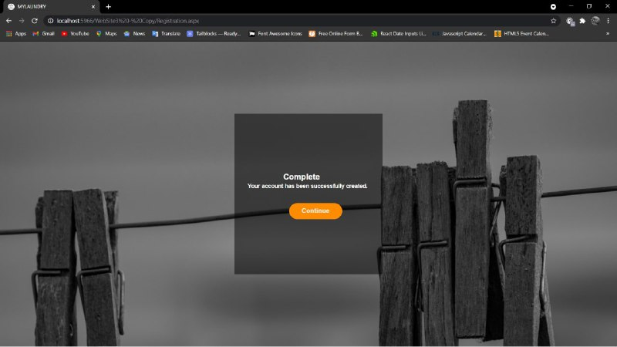

**Admin Panel**

* **Admin’s Dashboard**

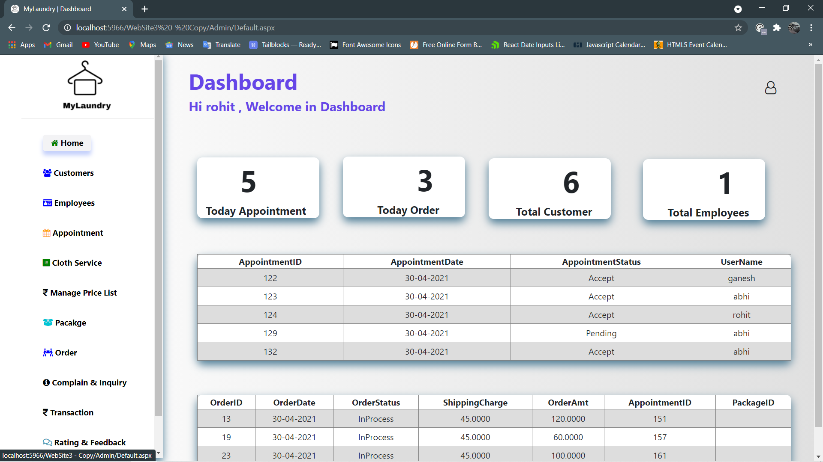

* **When Admin click on Profile.**

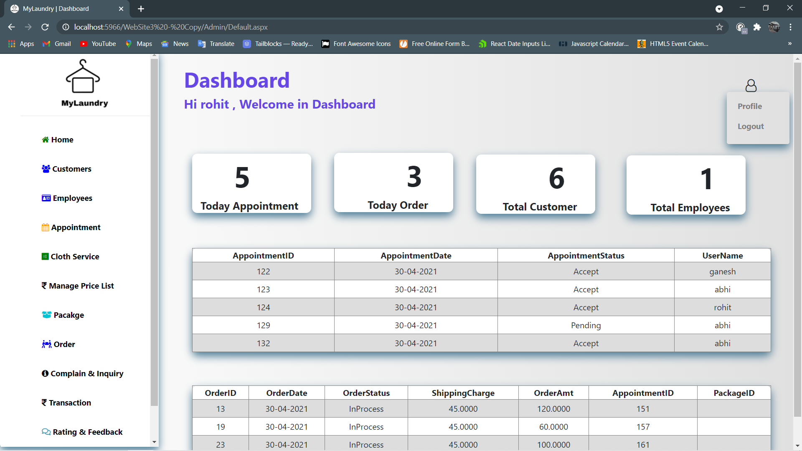

* **When admin wants to change any of His/Her details.**

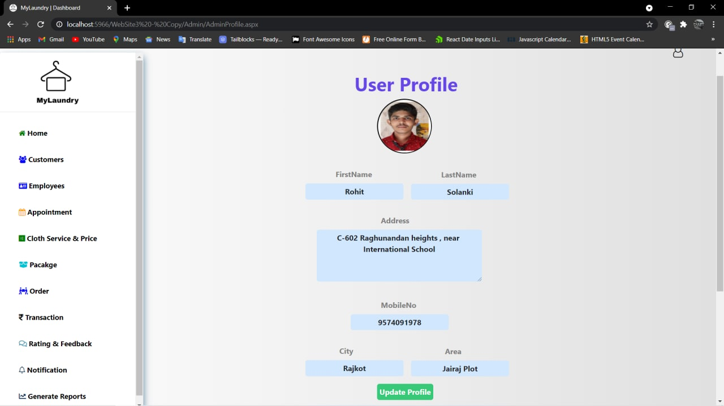

* **When admin wants to Change their Password**

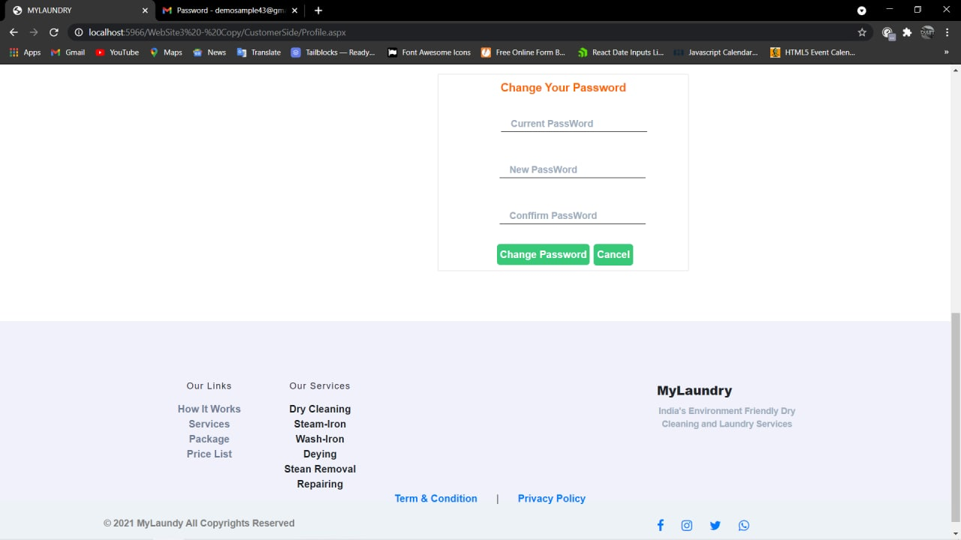

* **If Password and Confirm password don't match then error is shown.**

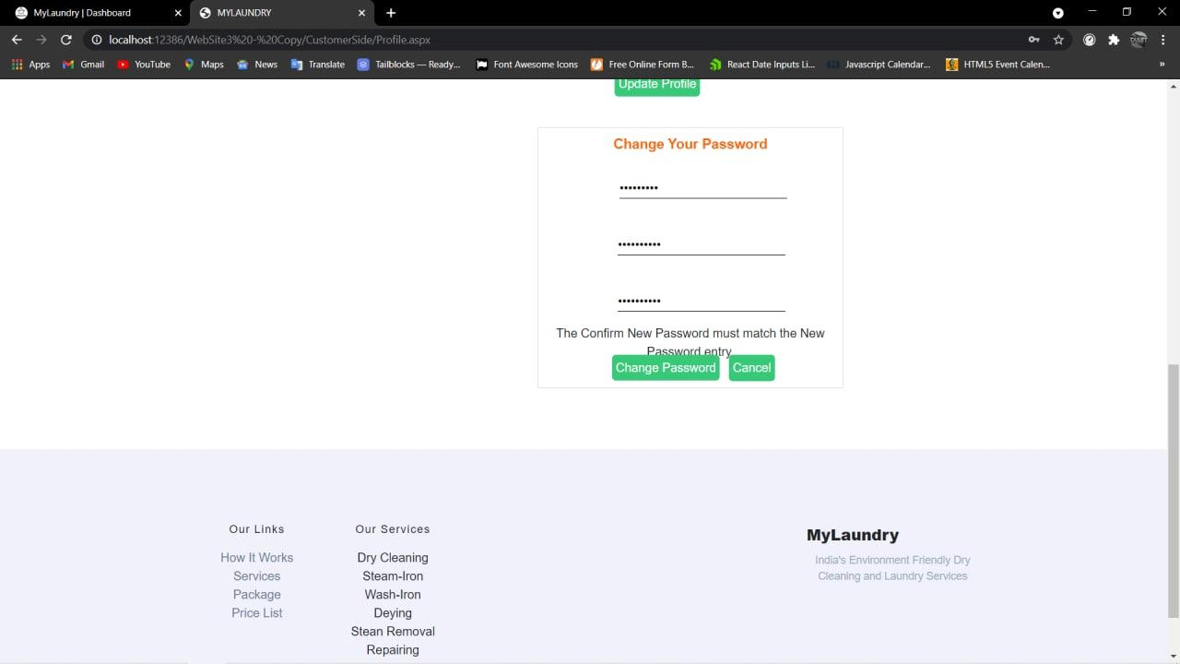

* **If Password and Confirm password are same, password changed successfully.**

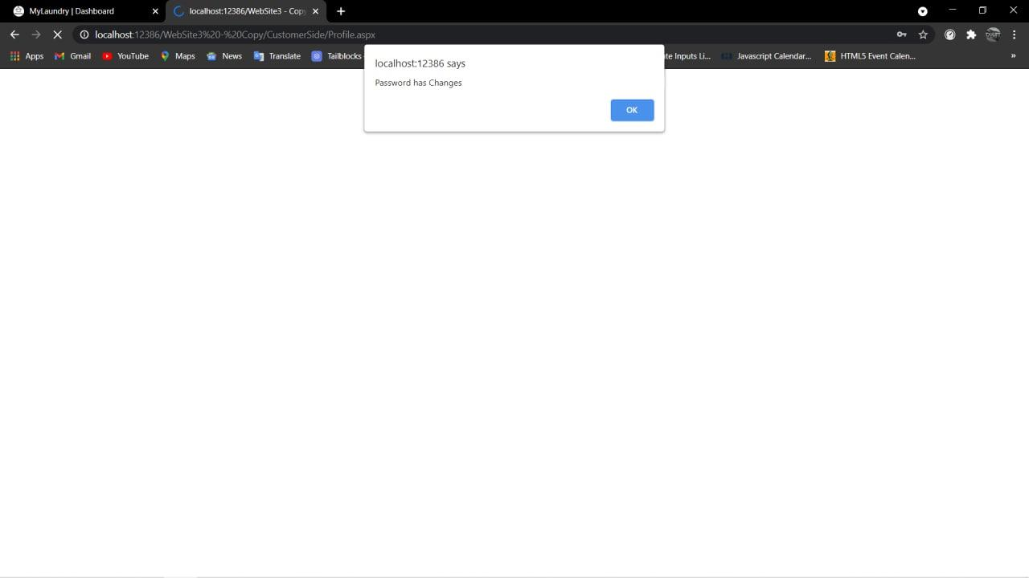

* **When admin clicks on Customer then admin can see customer Details.**

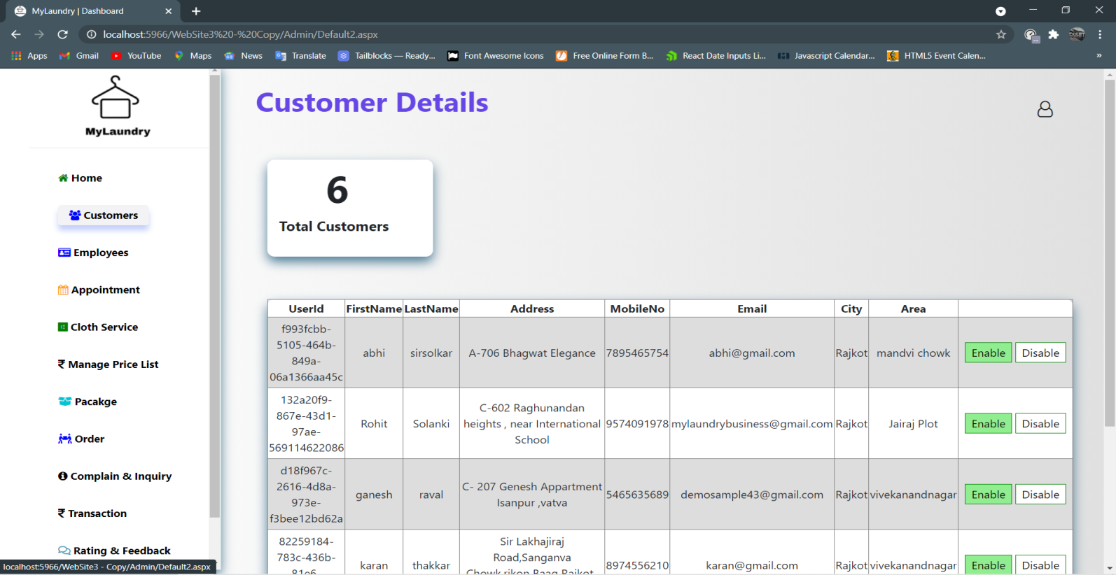

* **When Admin want to disable customer then they click on Disable.**

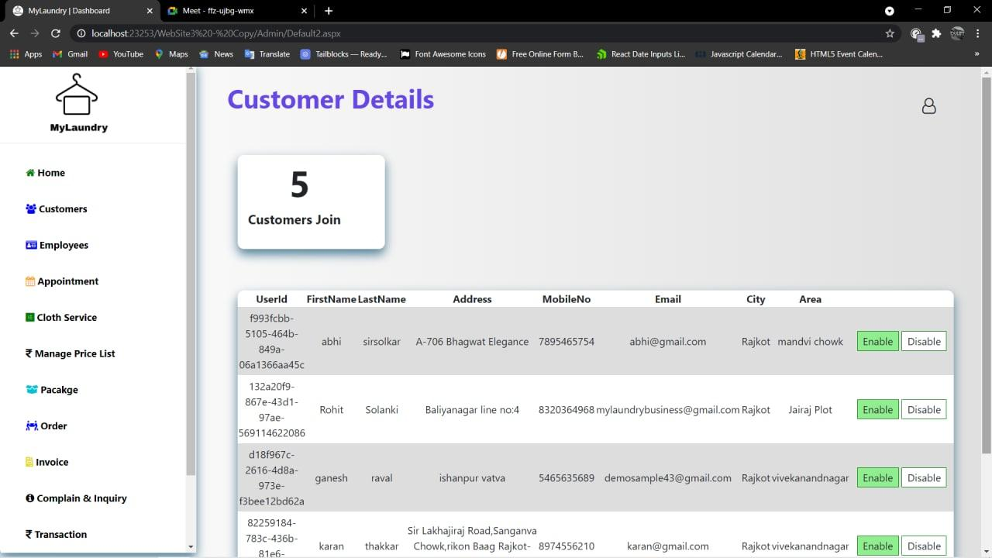

* **Customer Disable Successfully.**

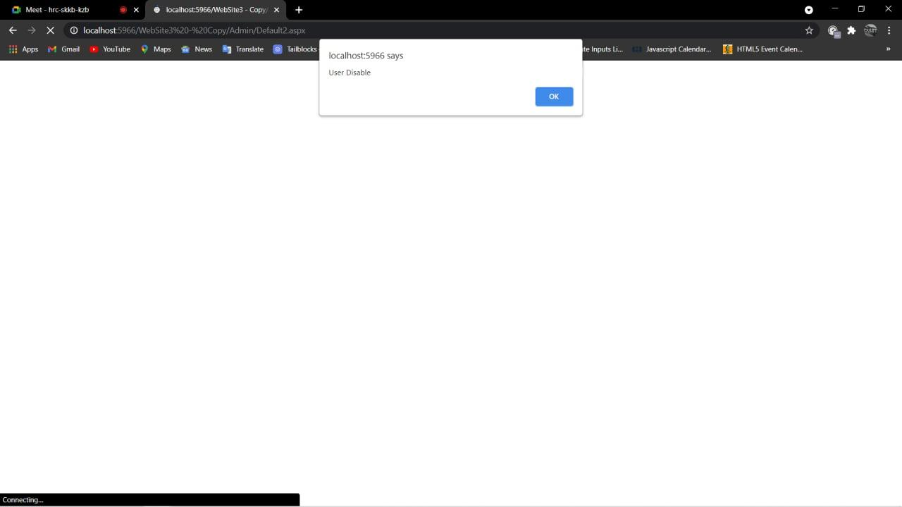

* **When Admin want to Enable customer then they click on Enable.**



* **Customer Enable Successfully.**

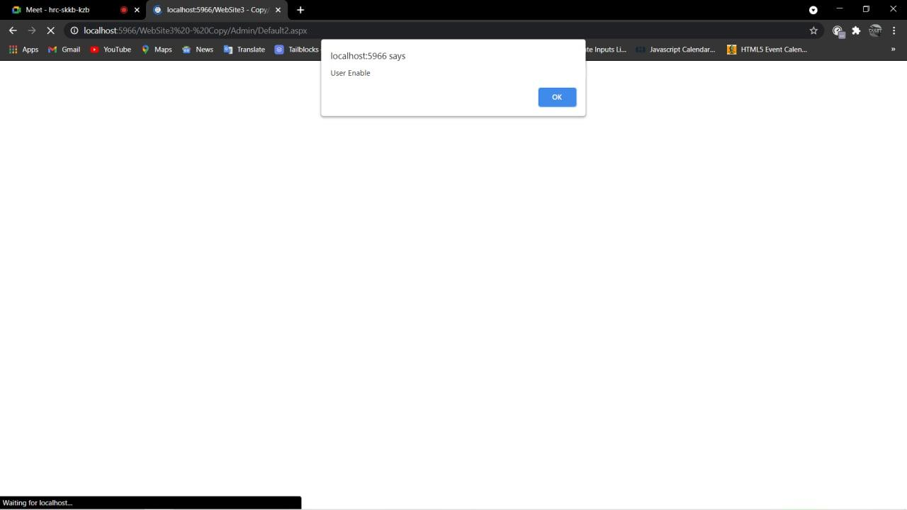

* **When admin clicks on Employee then admin can see Employee Details.**

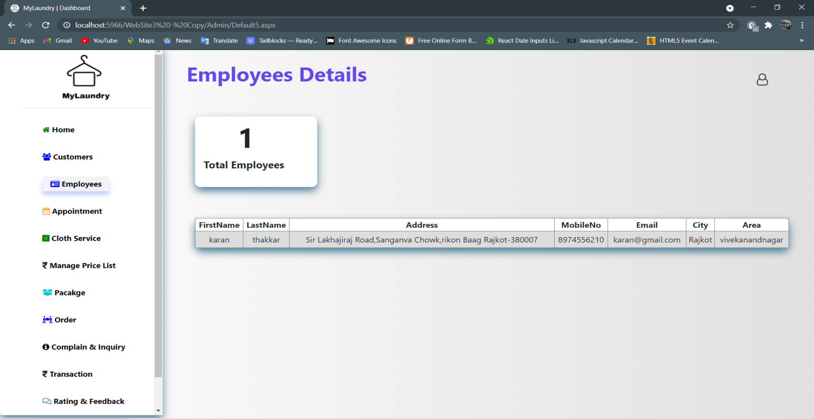

* **When admin clicks on Appointment then admin can see Appointment Details.**

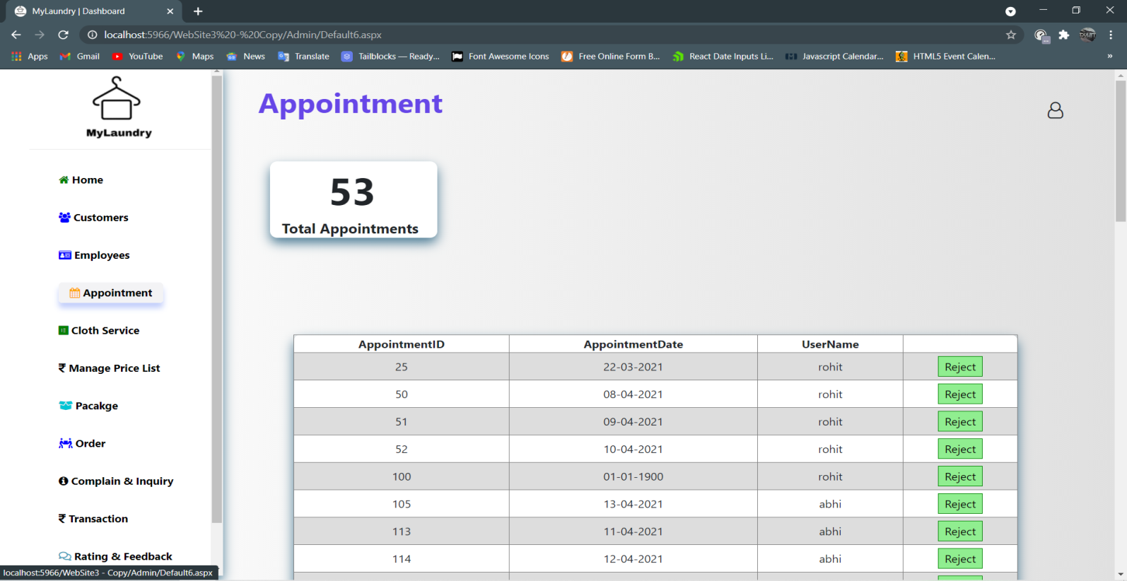

* **When admin clicks on Delete then customer will be notified by Mail.**

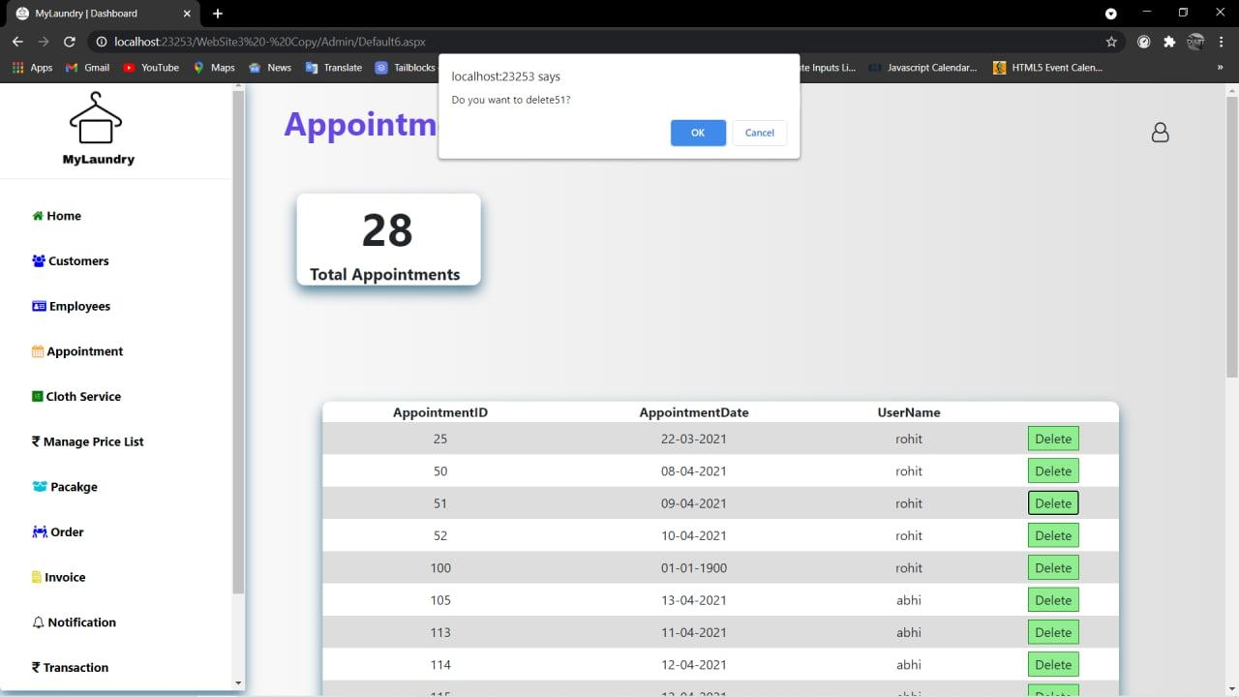

* **When admin clicks on Cloth Service then admin can see Cloth and Service Details.**

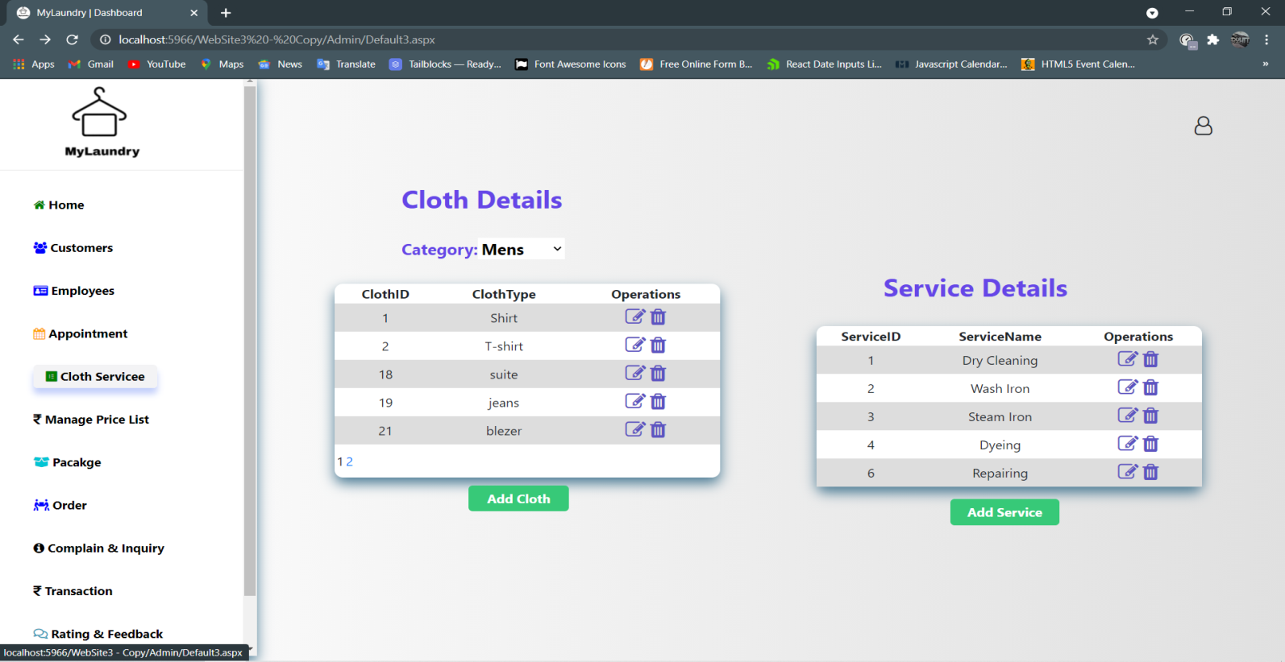

* **With the help of add cloth button admin can add new cloth type.**

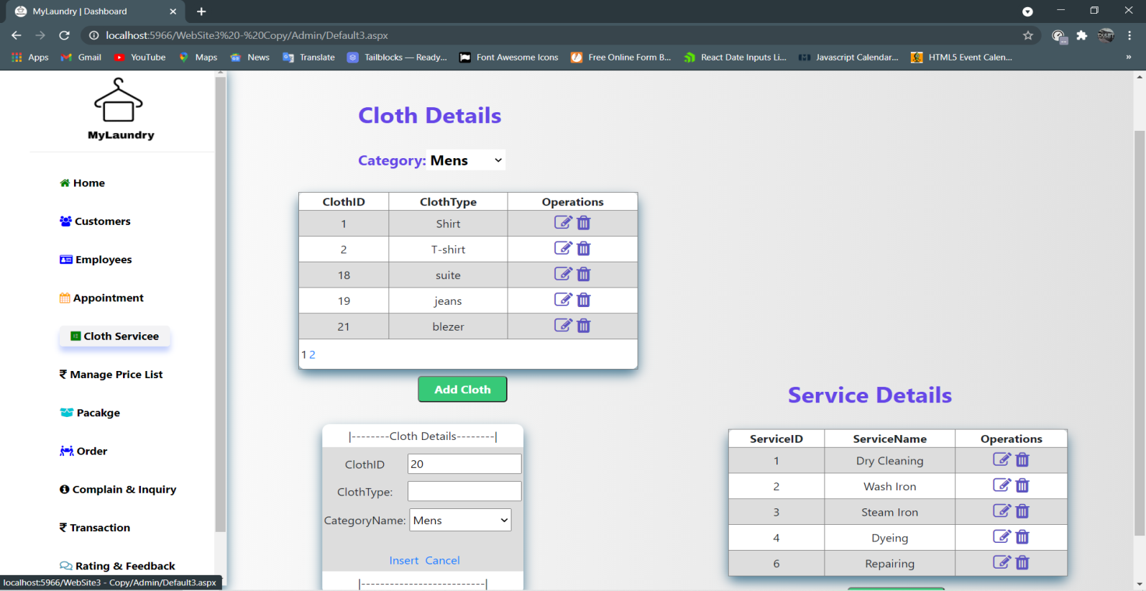

* **Without entering clothtype if admin clicks on insert button then error shown.**

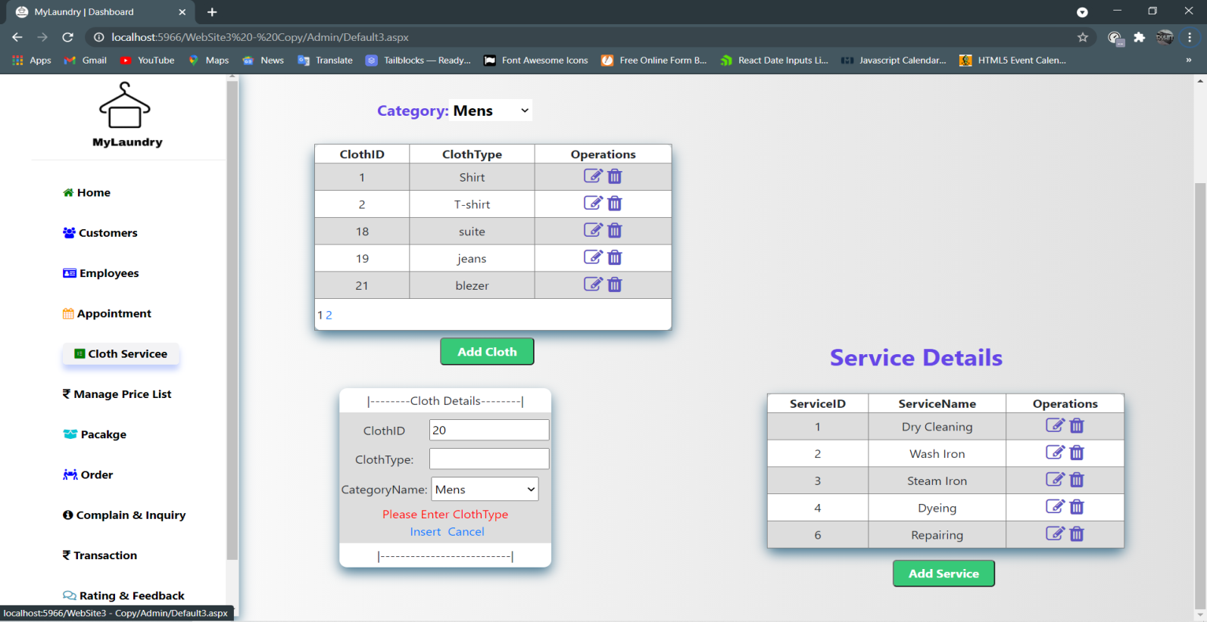

* **With the help of add service button admin can add new service.**

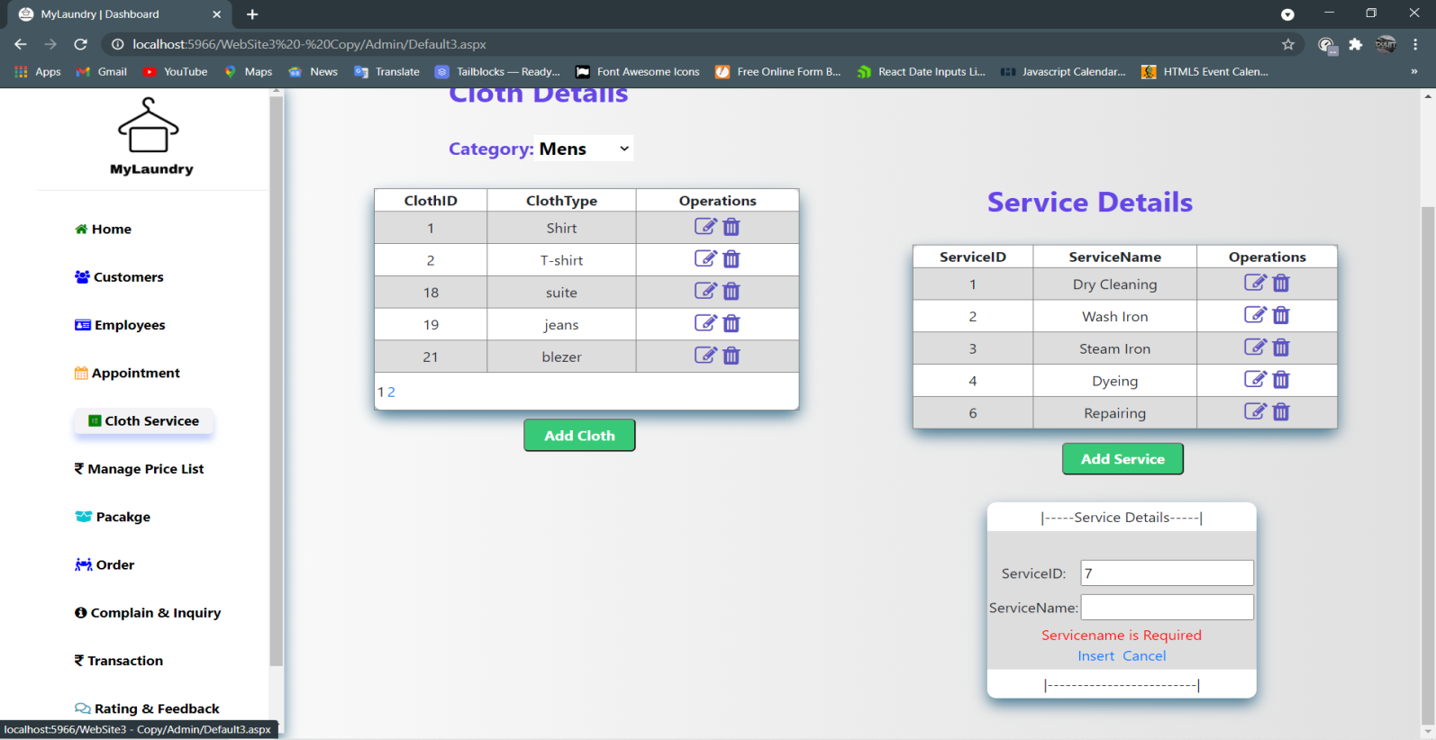

* **Without entering service if admin clicks on insert button then shown error.**

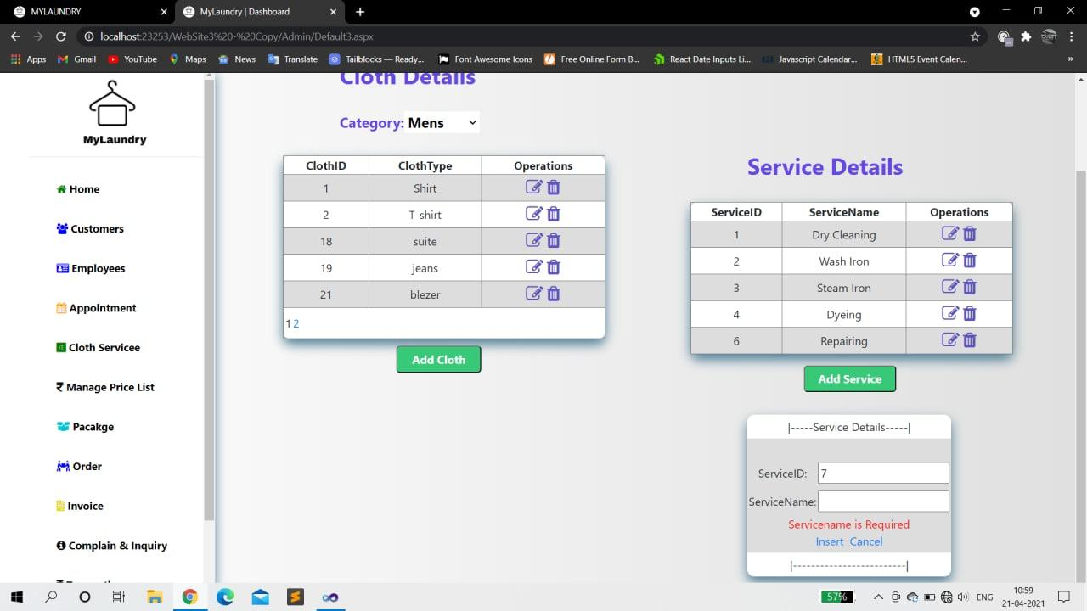

* **When admin clicks on price list then admin can see price details according their cloth type and service.**

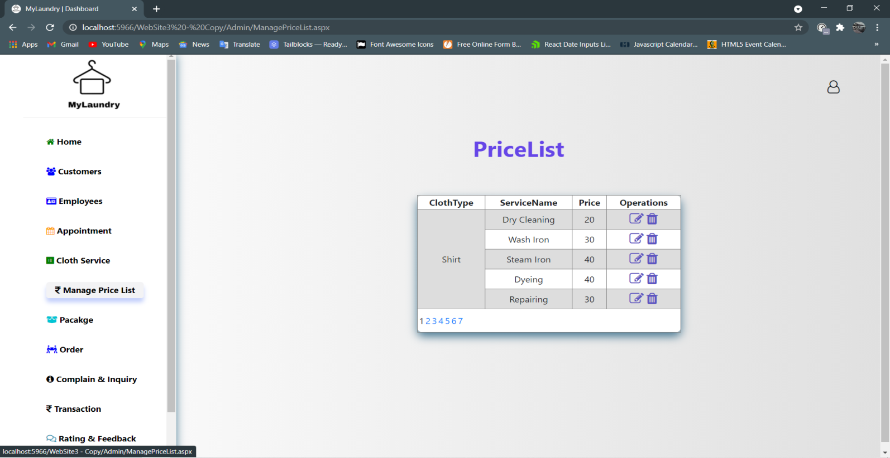

* **When admin clicks on Package then admin can see package Detail.**

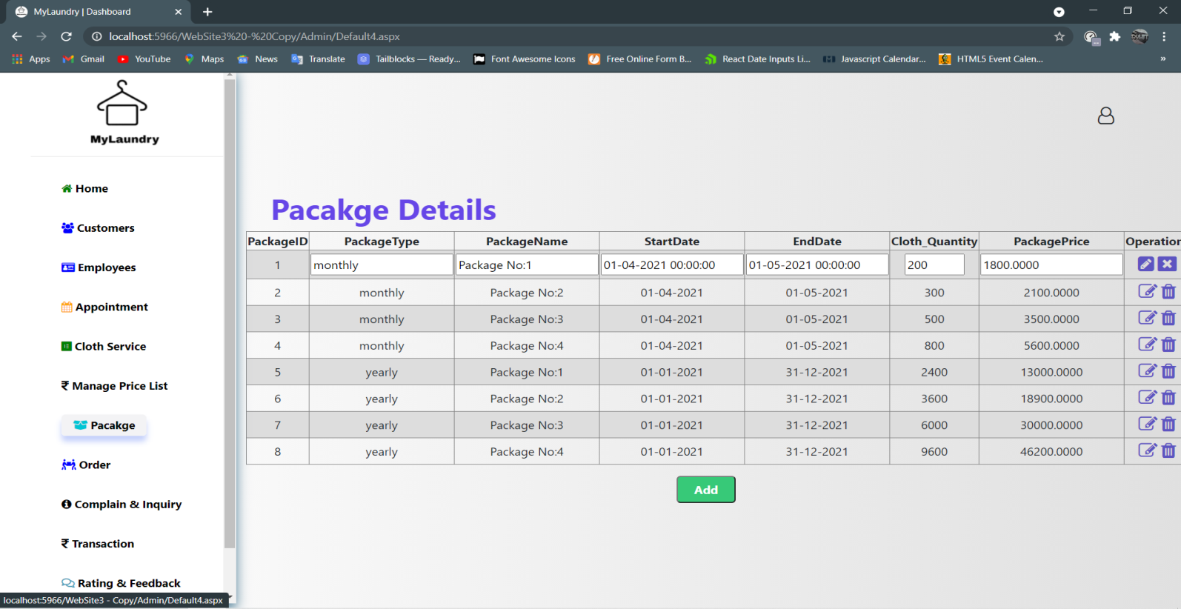

* **If admin wants to add new package then click on Add button.**

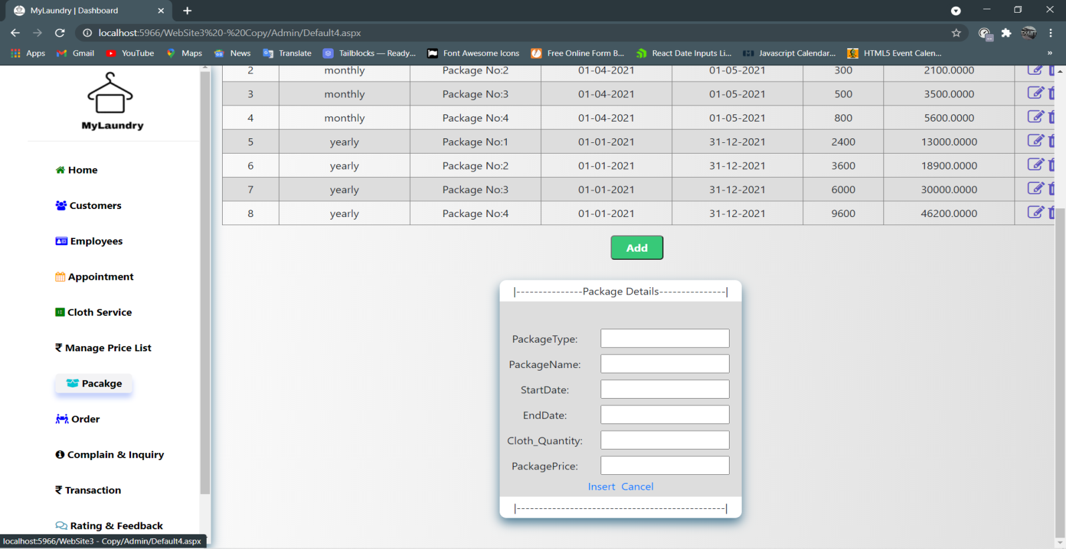

* **When admin clicks on Order then admin can see Order Detail.**

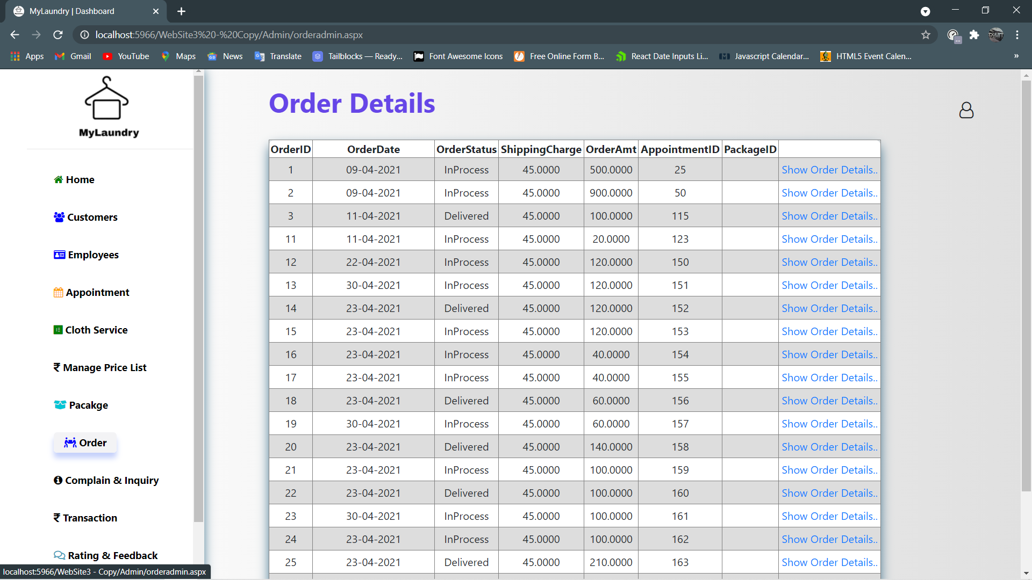

* **Order Detail Displayed.**

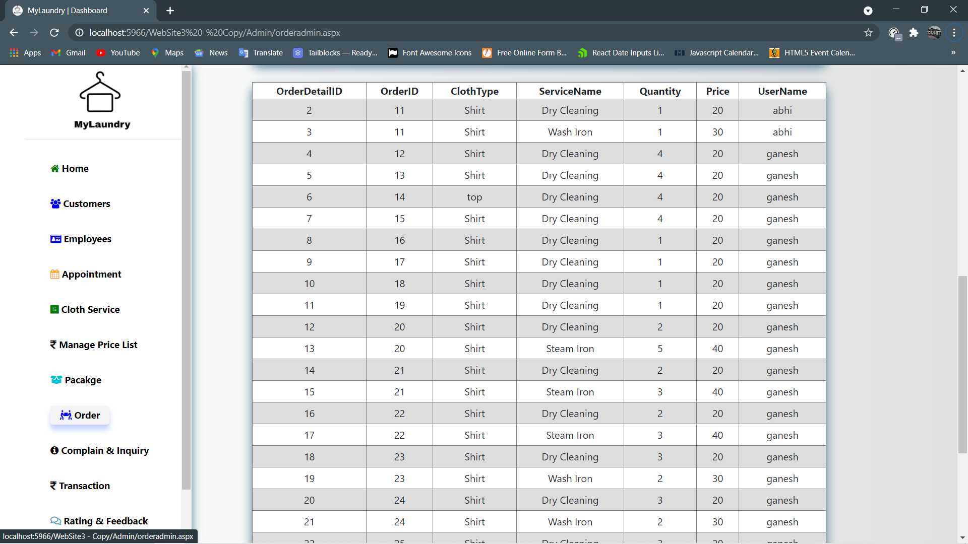

* **When admin clicks on Complain & Inquiry then admin can see complain & complain detail.**

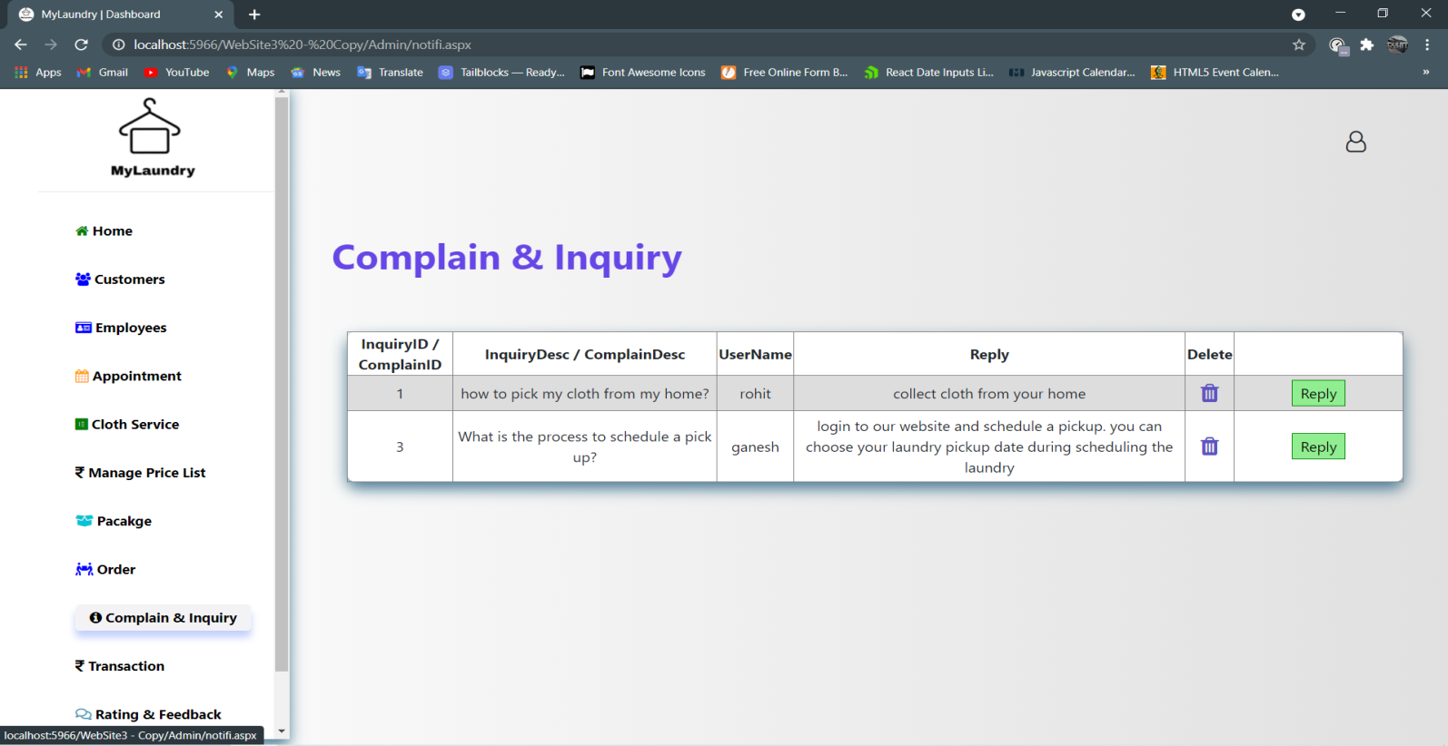

* **Admin can type message and click on send to reply to customer.**

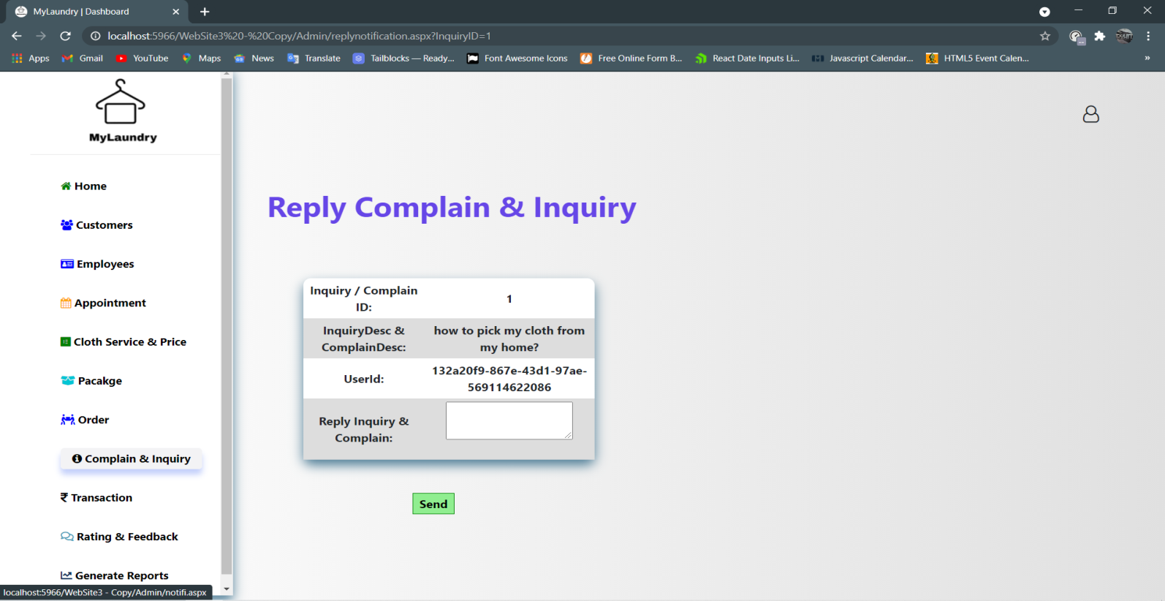

* **When admin clicks on Rating & Feedback then admin can see Rating & Feedback Detail.**

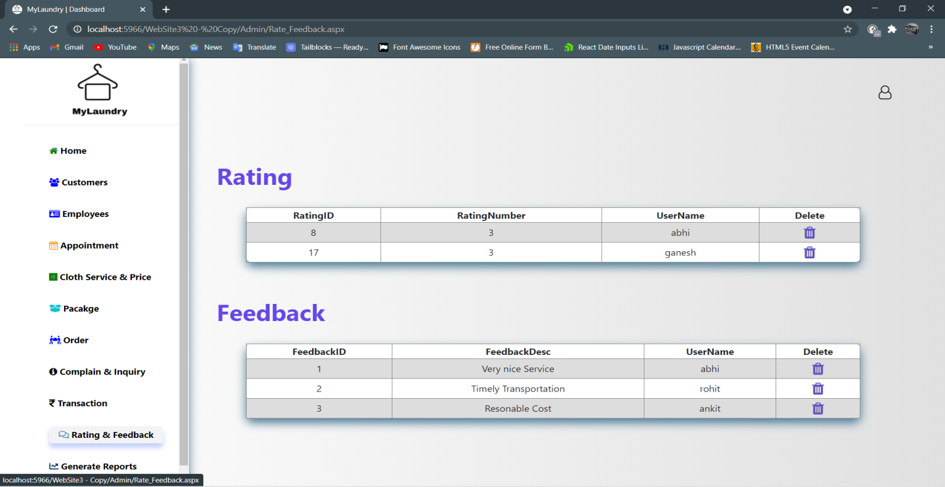

**Customer Panel**

* **Customer’s Home page**

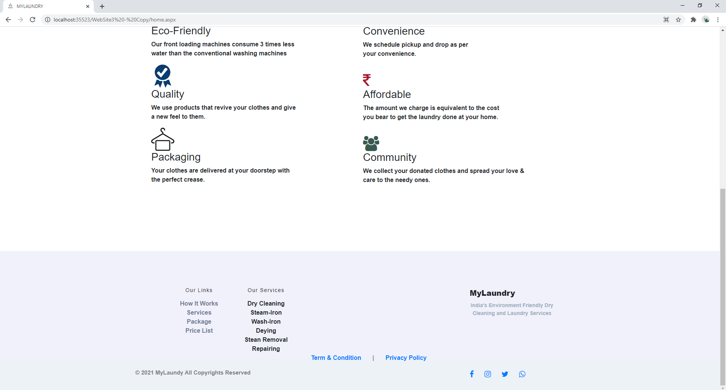

* **When Customer clicks on ‘How-It-Works’.**

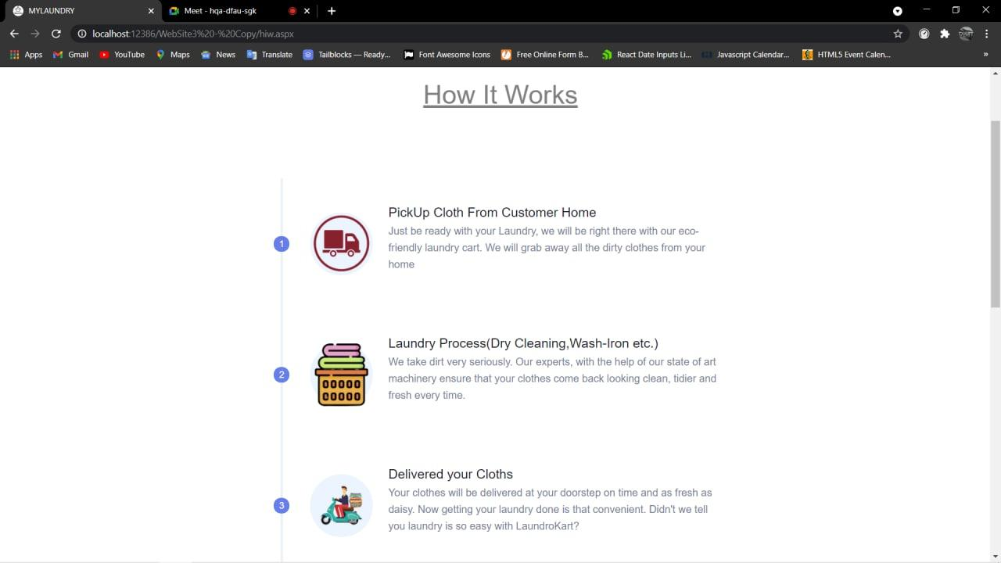

* **When Customer Clicks on ‘Laundry Services’.**

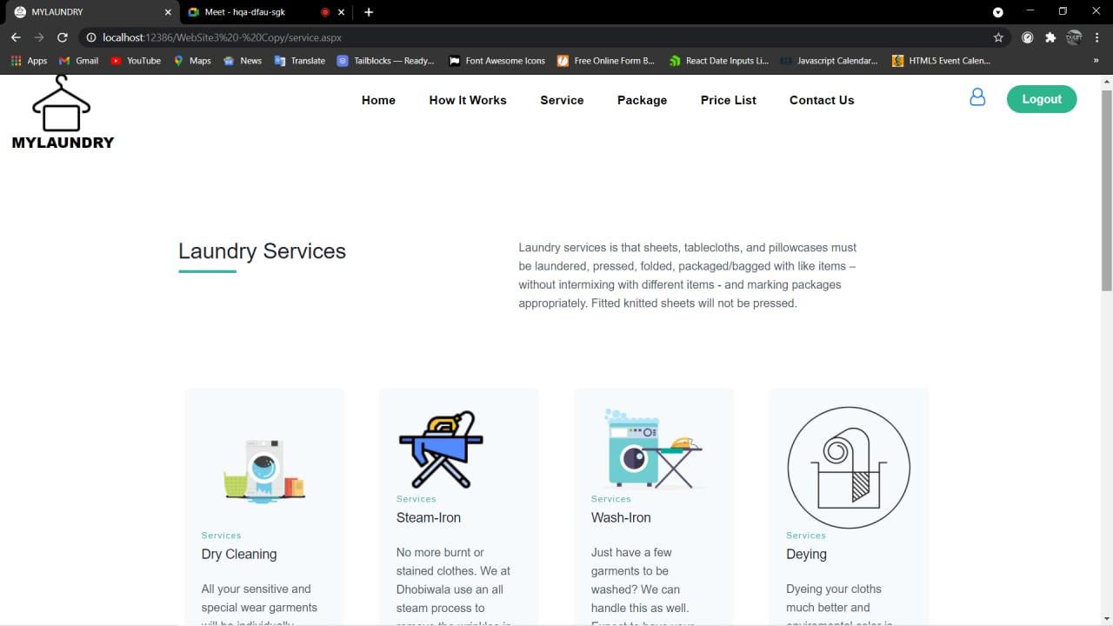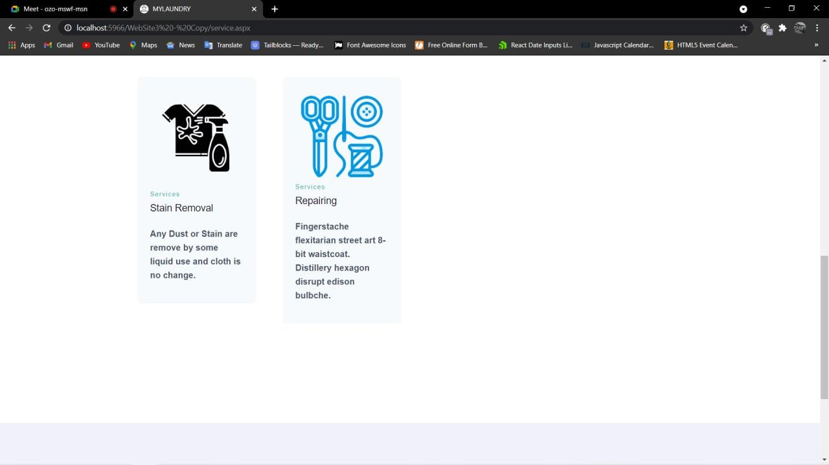

* **When clicked on ‘Package’ then quantity based Package details are Shown.**

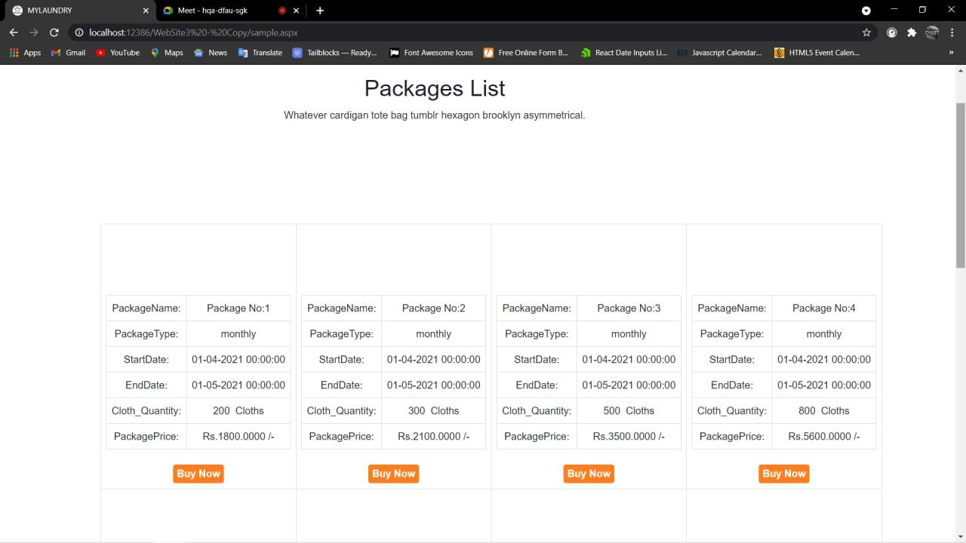 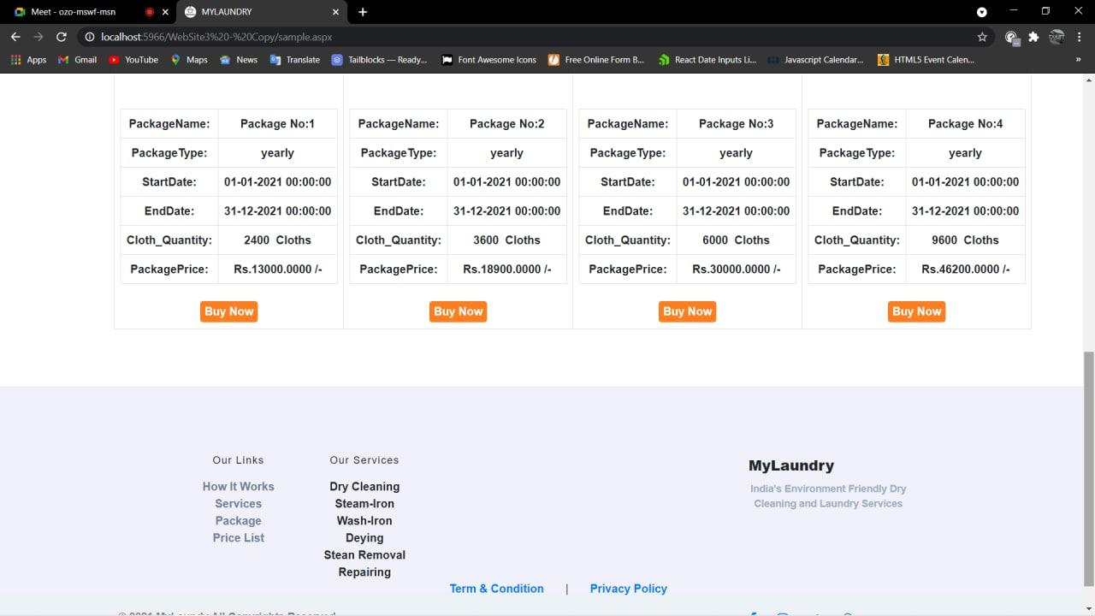

* **When clicked on ‘PriceList’ then according to cloth and service, prices are shown.**

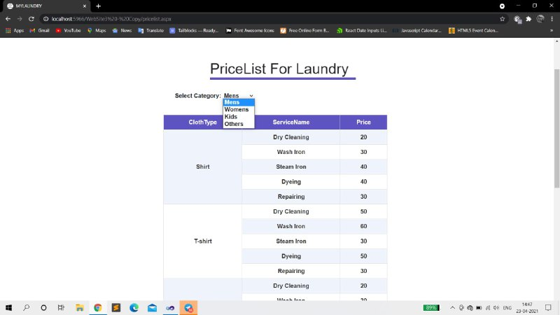

* **When clicked on DropDown and select ‘Women’ then accordingly women’s cloth and service price are shown.**

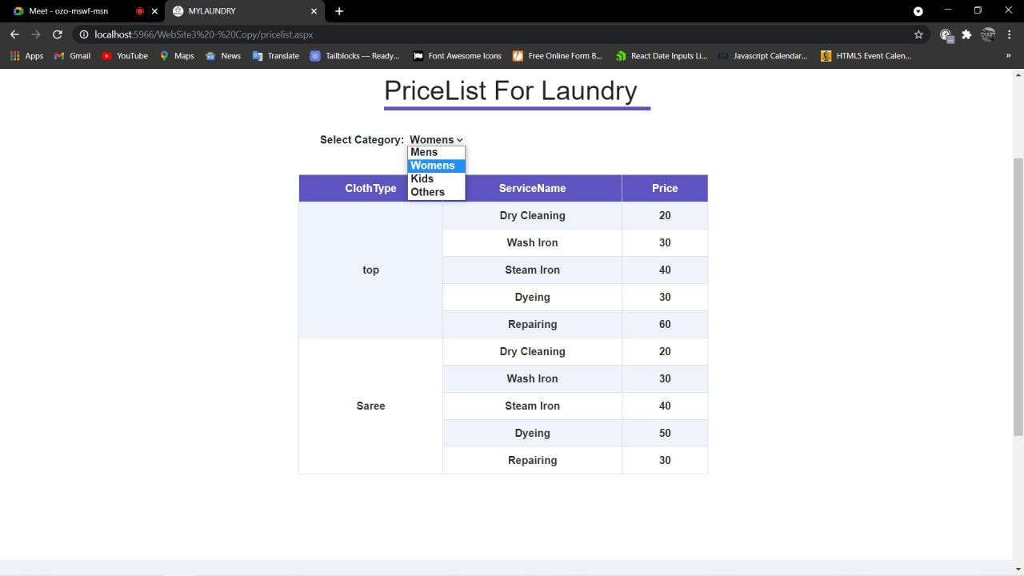

* **When customer wants to change any of their details.**

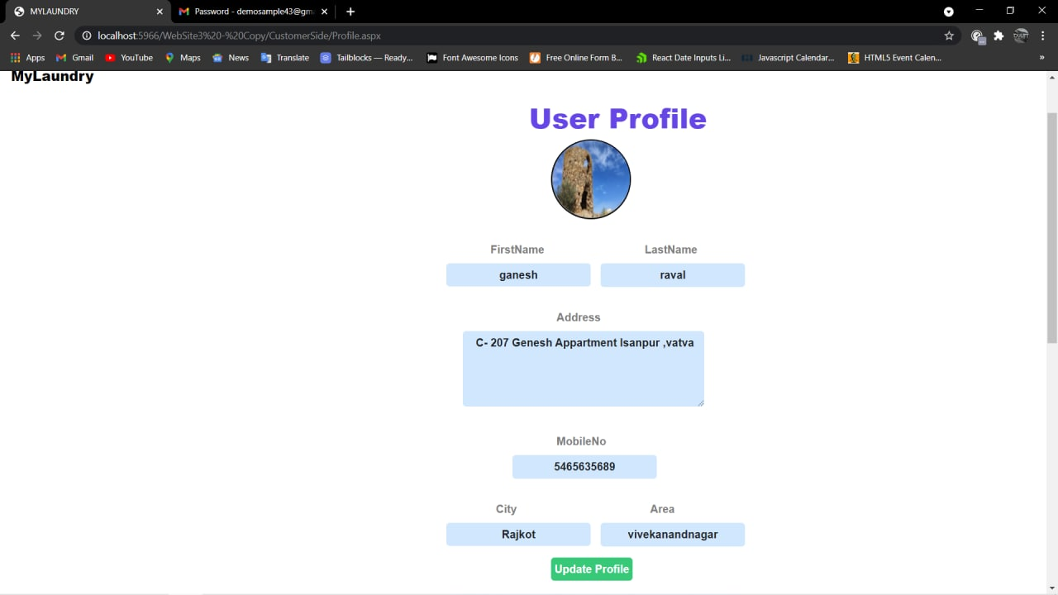

* **When customer wants to Change their Password.**



* **If Password and Confirm password don't match then error shown.**



* **If Password and Confirm password are same then password changed successfully.**



* **When user clicks on Book Now.**



* **Appointment Form shown.**

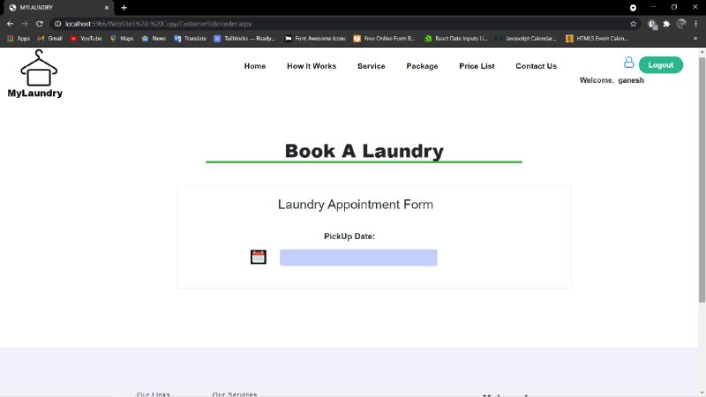

* **When user clicks on Calendar Control.**

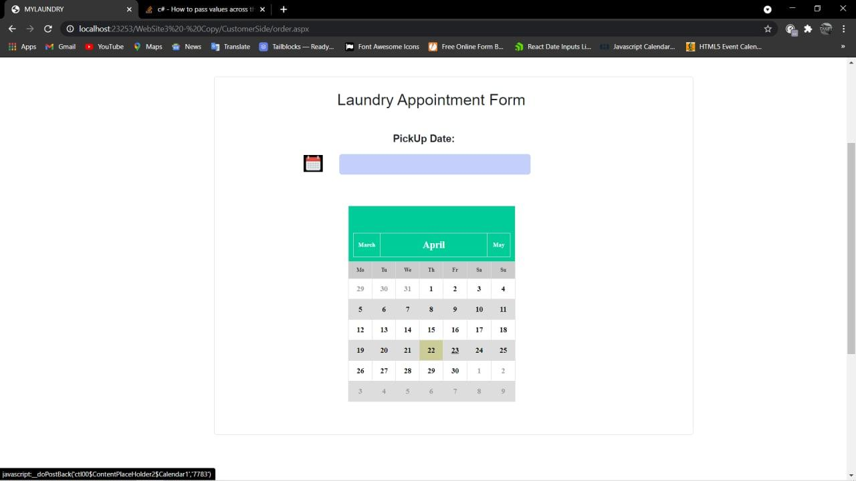

* **Successful Appointment Request**

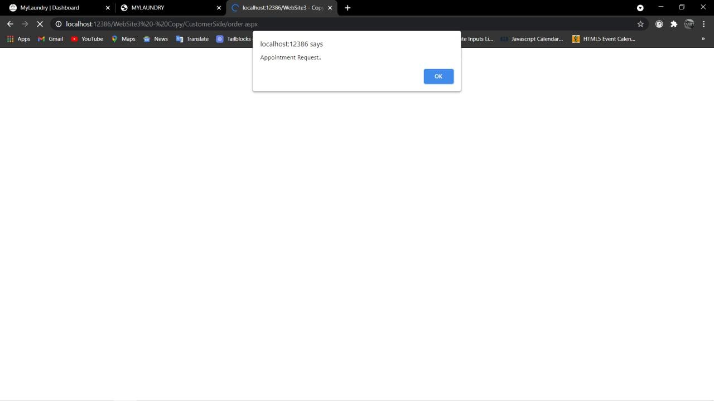

* **Customer can delete Appointment.**

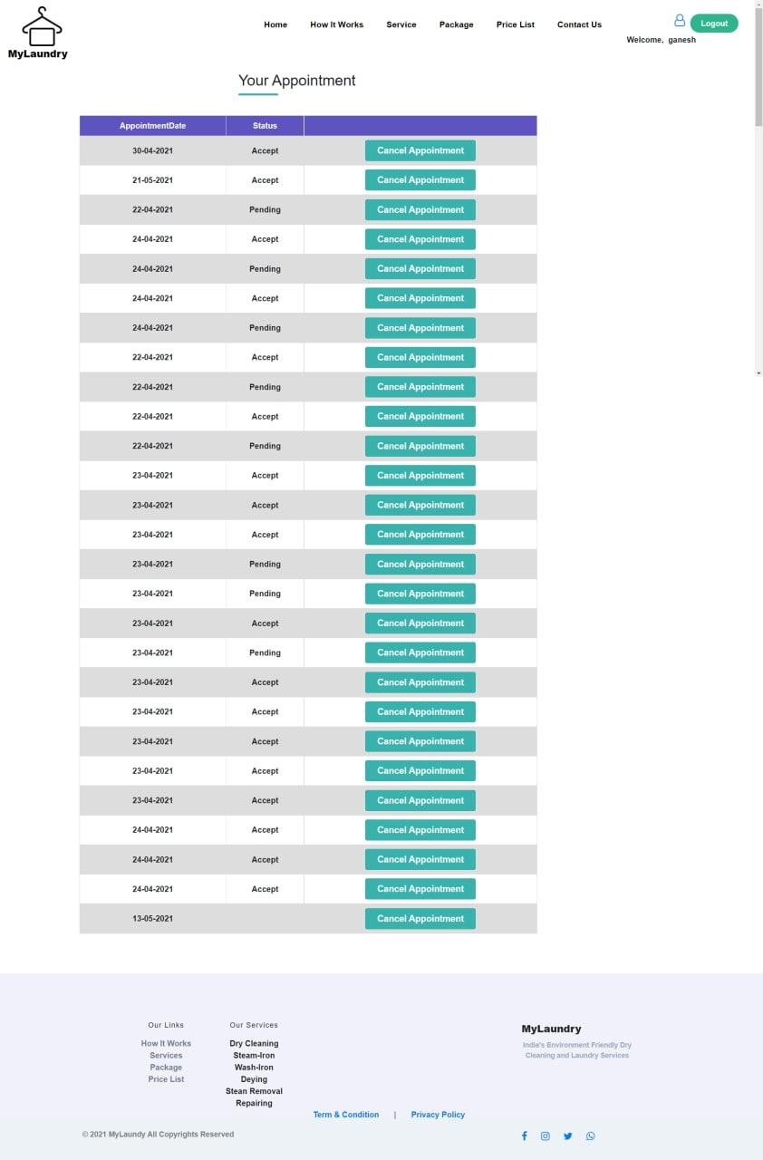

* **When Admin Rejects customer appointment then customer receiving mail.**

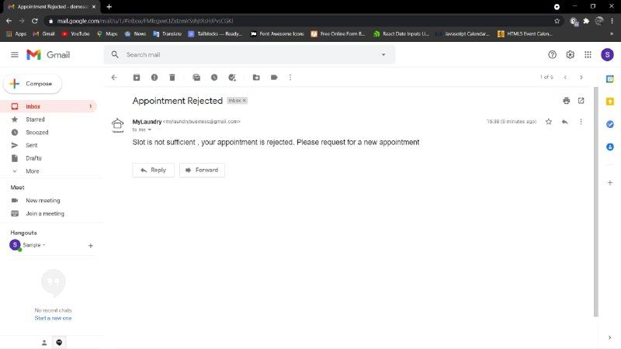

* **Then we need to enter our details.**

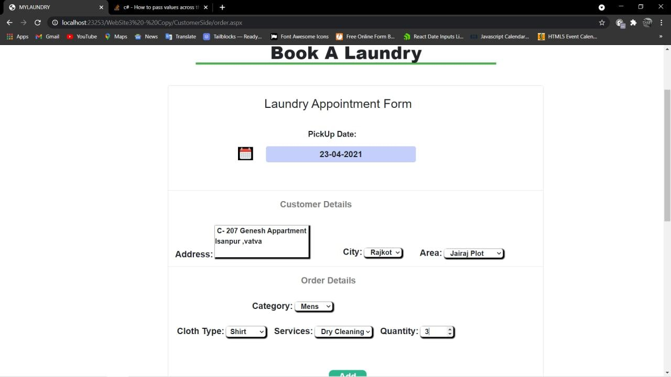

* **When we don’t enter Quantity then error is shown.**

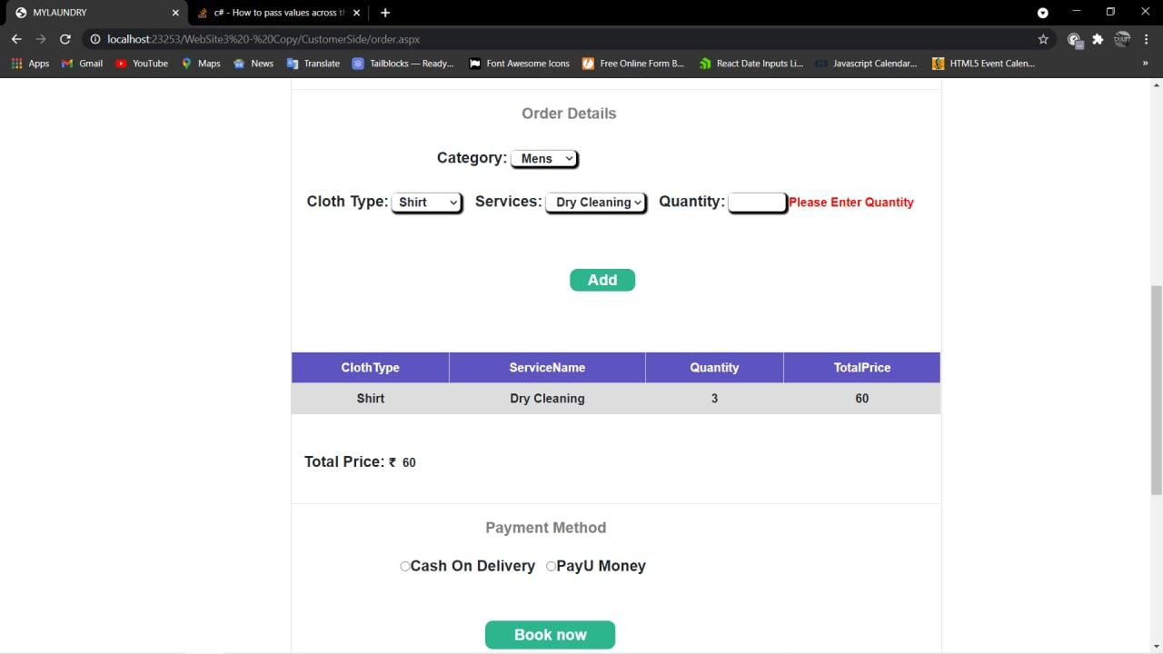

* **When we enter correct ClothType, Service and quantity then details are stored in Gridview .**

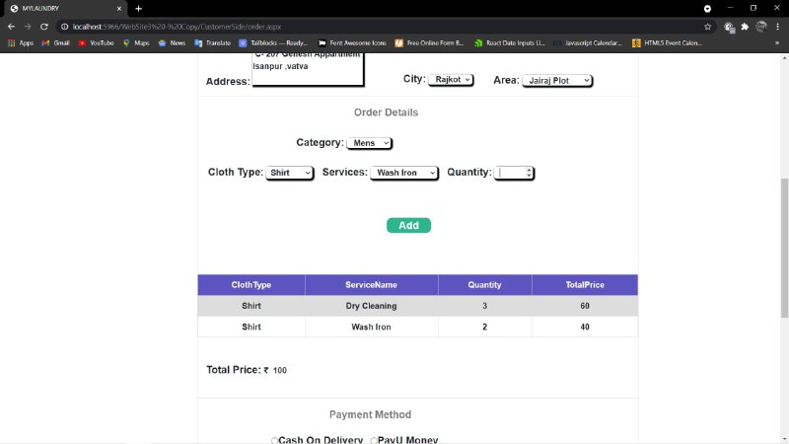

* **User selecting payment method.**

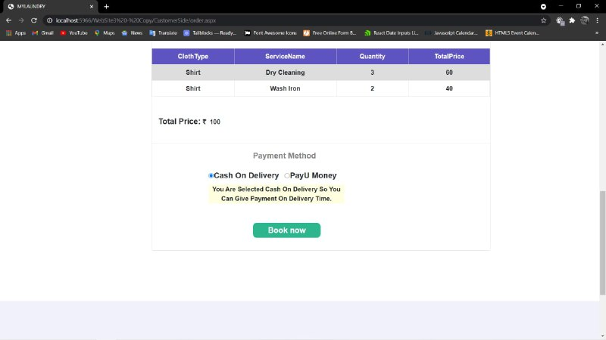

* **User want to pay through the PayU Money.**

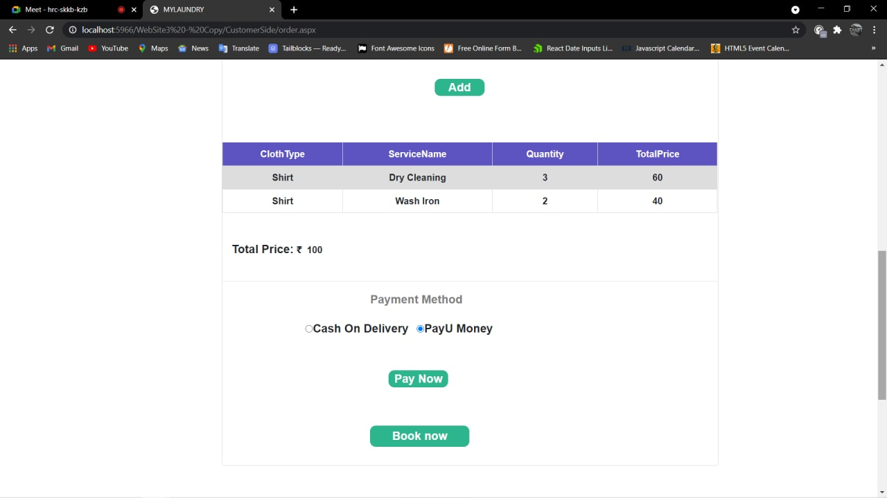

* **Customer want to add their Detail.**

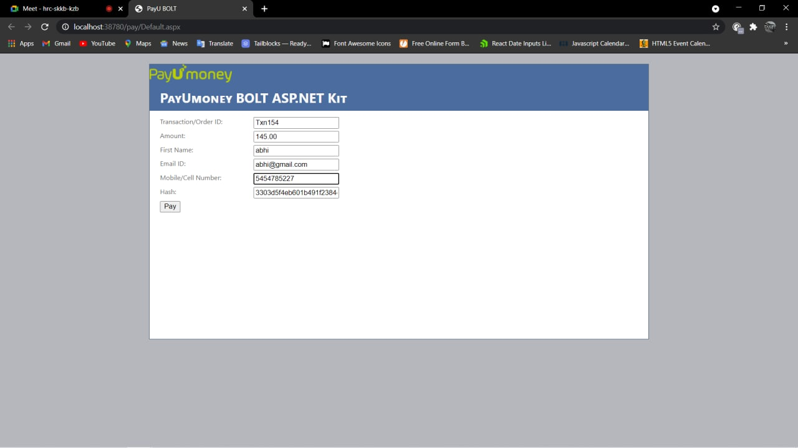

* **After that customer want to add their card detail.**

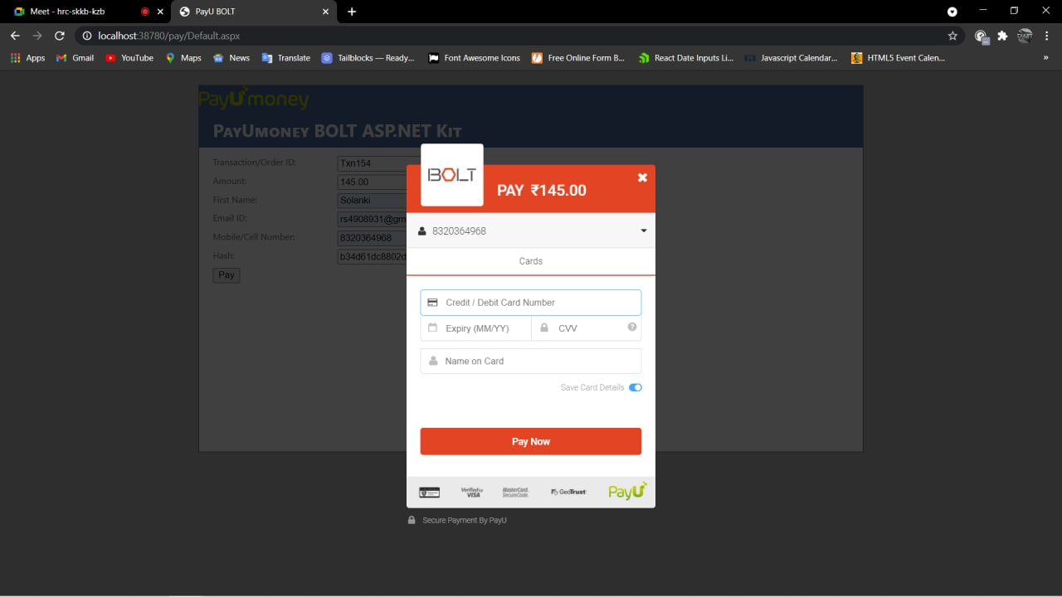

* **After adding customer card detail customer click on pay now.**

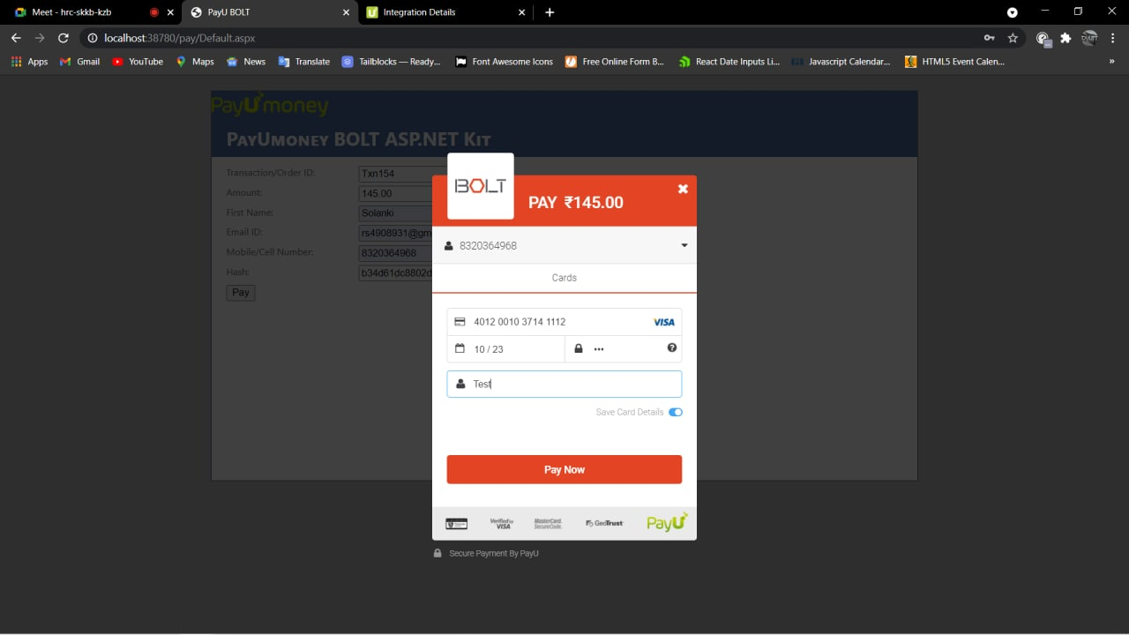

* **Customer receiving OTP.**

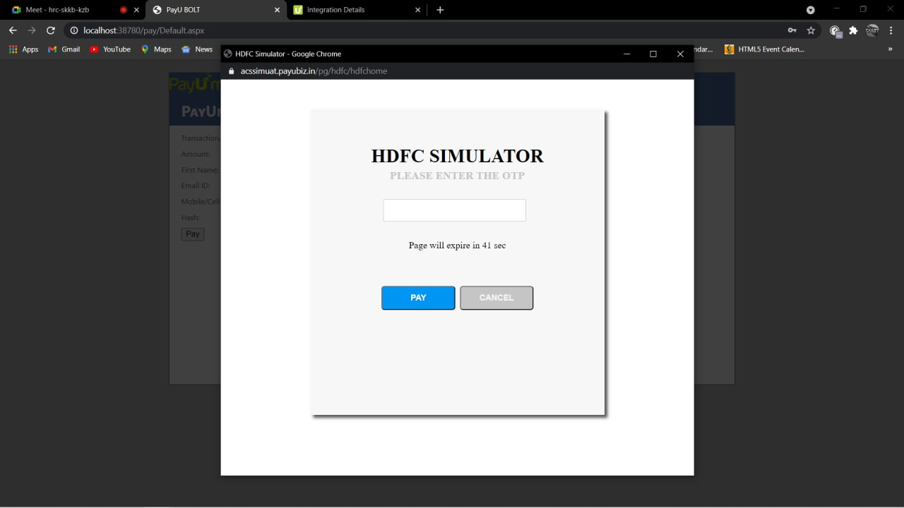

* **If the customer enter wrong OTP then transaction failed.**

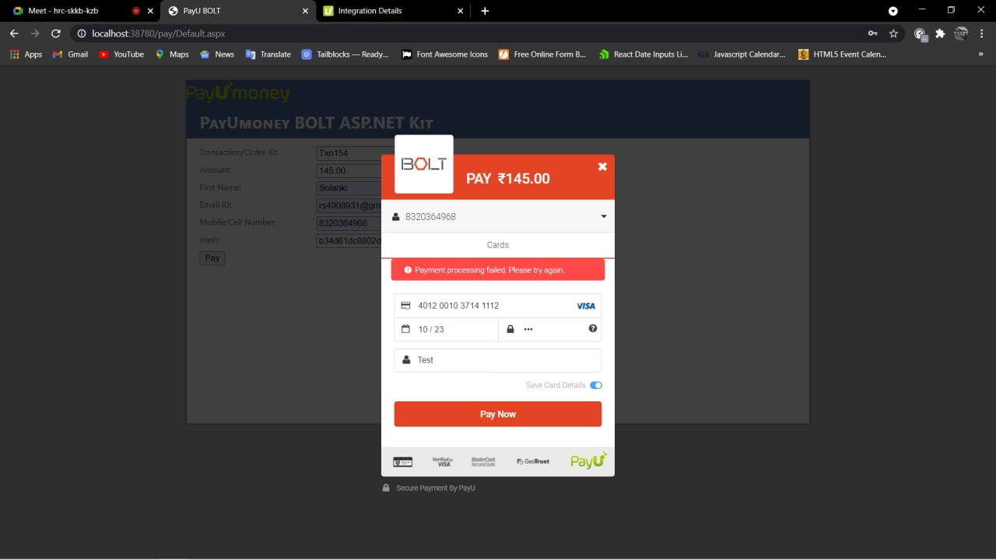

* **If the customer enter correct OTP then transaction completed.**

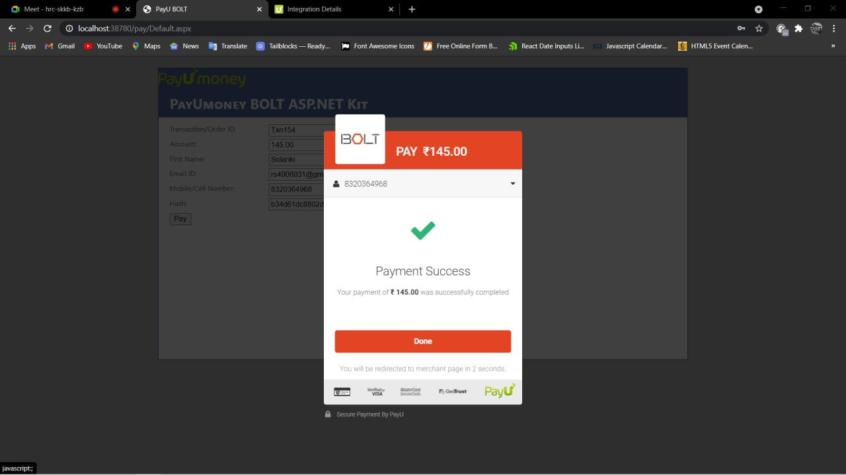

* **Invoice displayed to user.**

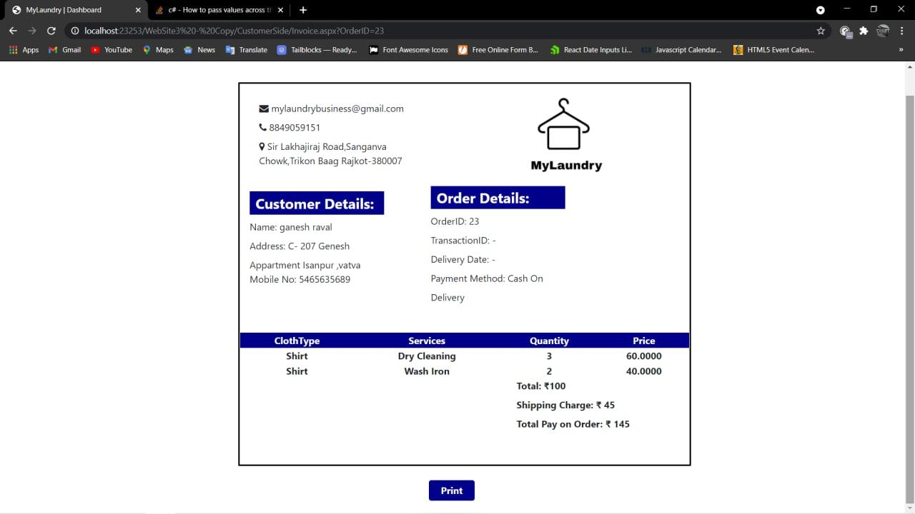

* **When user clicks on print button then user can printout their invoice.**

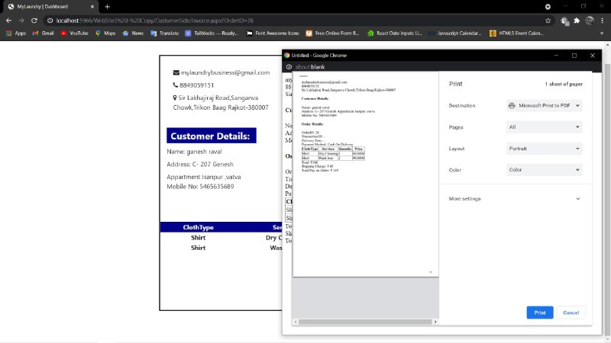

* **When user clicks on Order History then according their orders, Order History is shown.**



* **Order history Displayed and when user clicks on Show order details.**

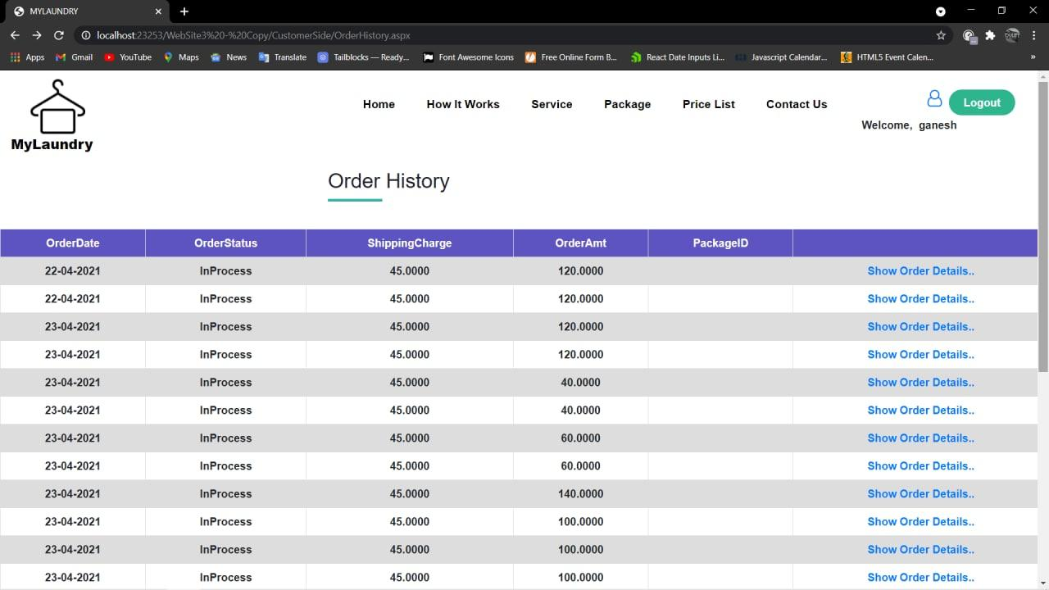

* **Order Details Displayed.**

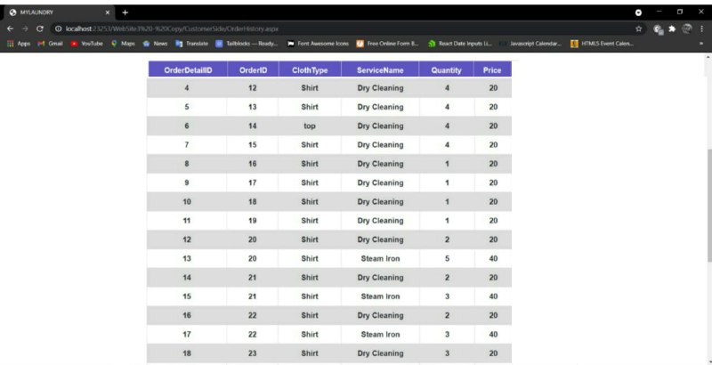

* **If customer has any Inquiry then they type it and Send it to Admin.**

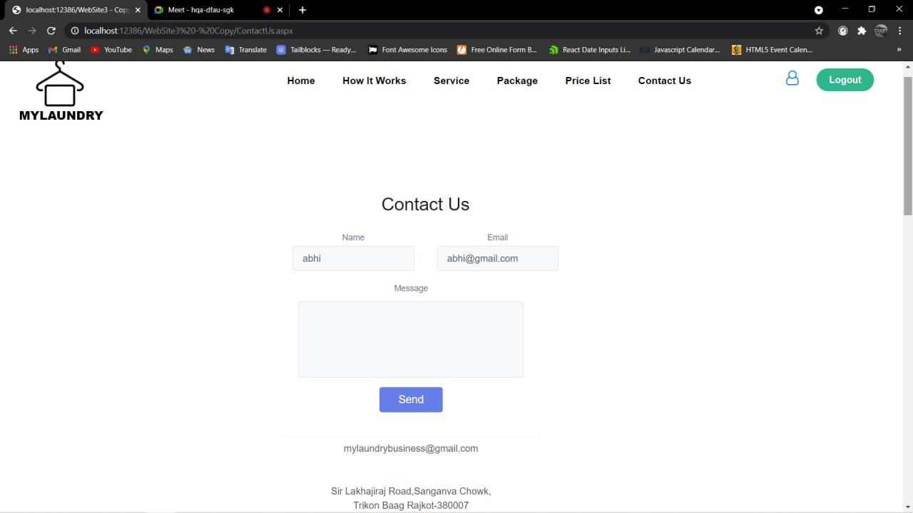

* **Customer’s Inquiry sent successfully.**

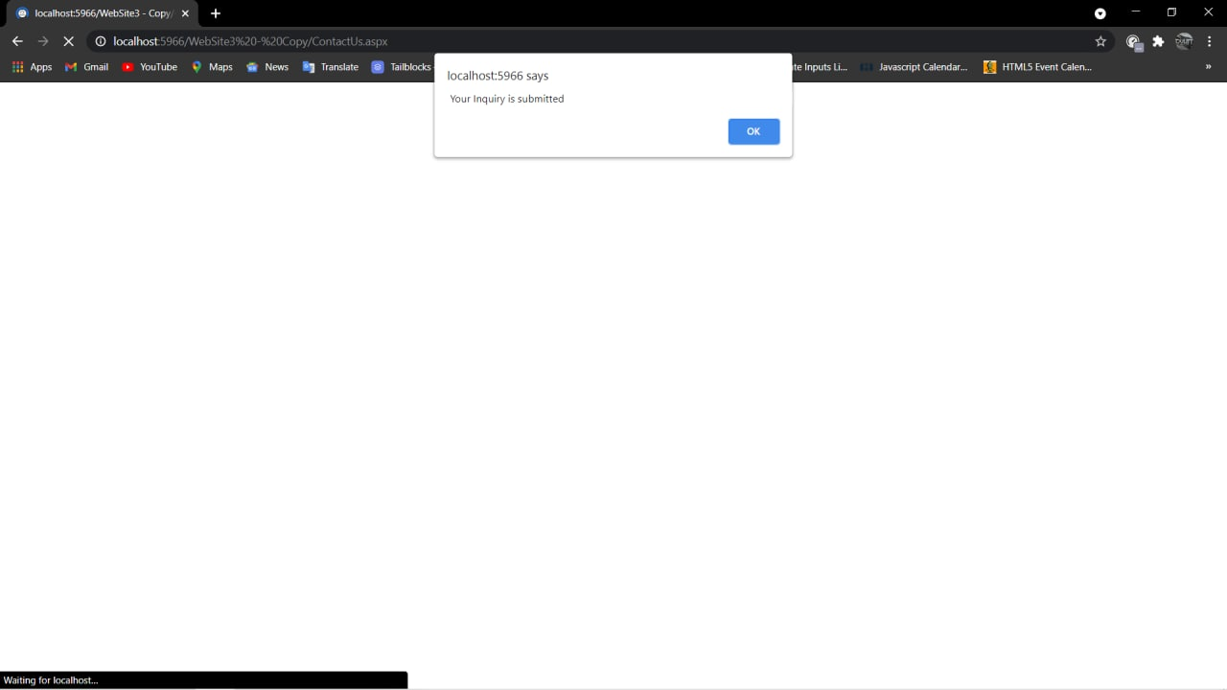

* **Admin’s reply to Customer about their inquiry.**

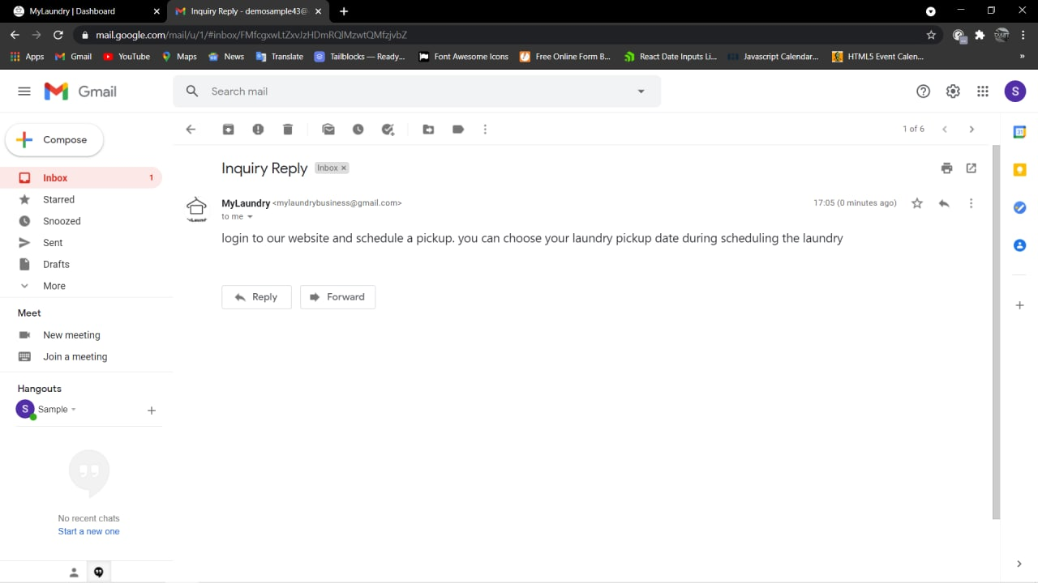

* **Customer can give Ratings and Feedback.**

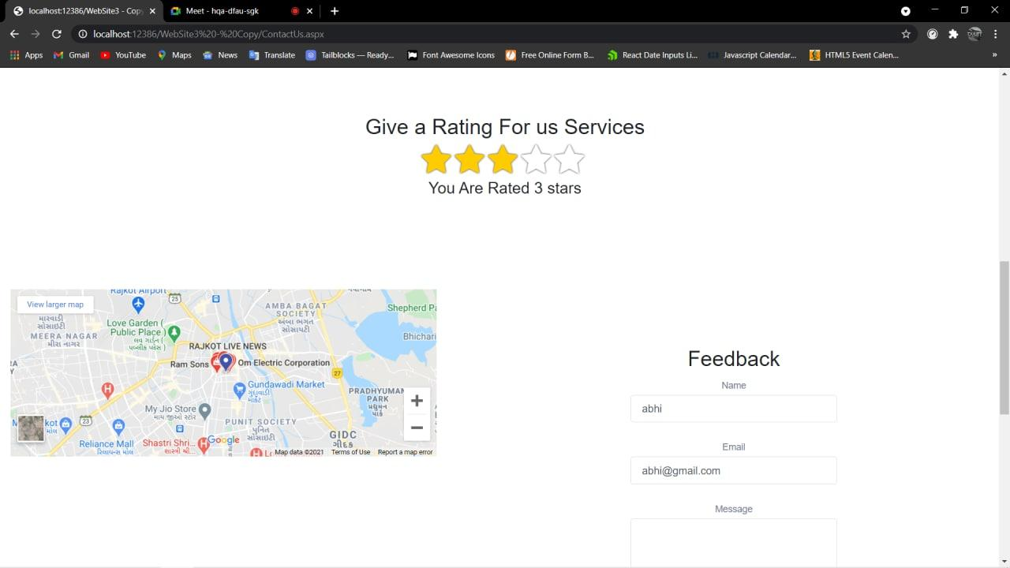

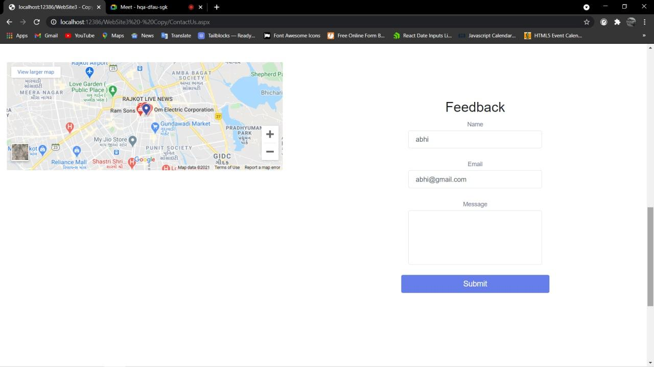

* **Terms & Conditions**

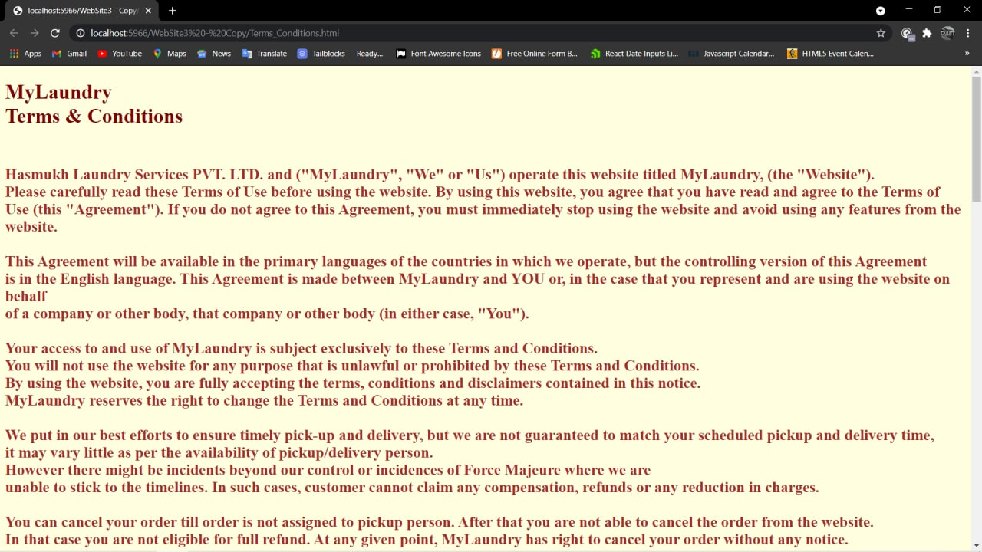

* **Privacy Policy**

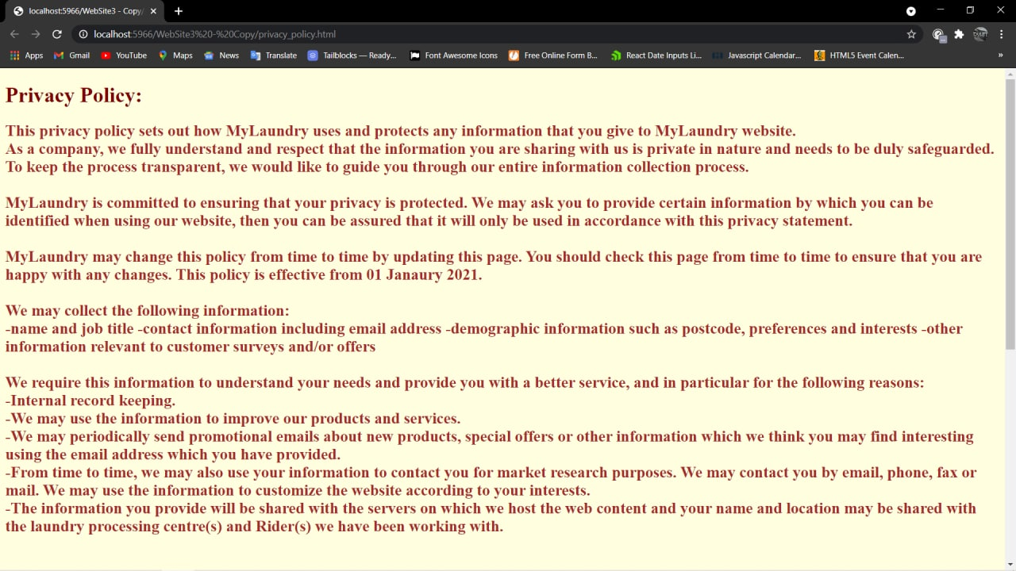

**Reports**

* **Daily Order Report**

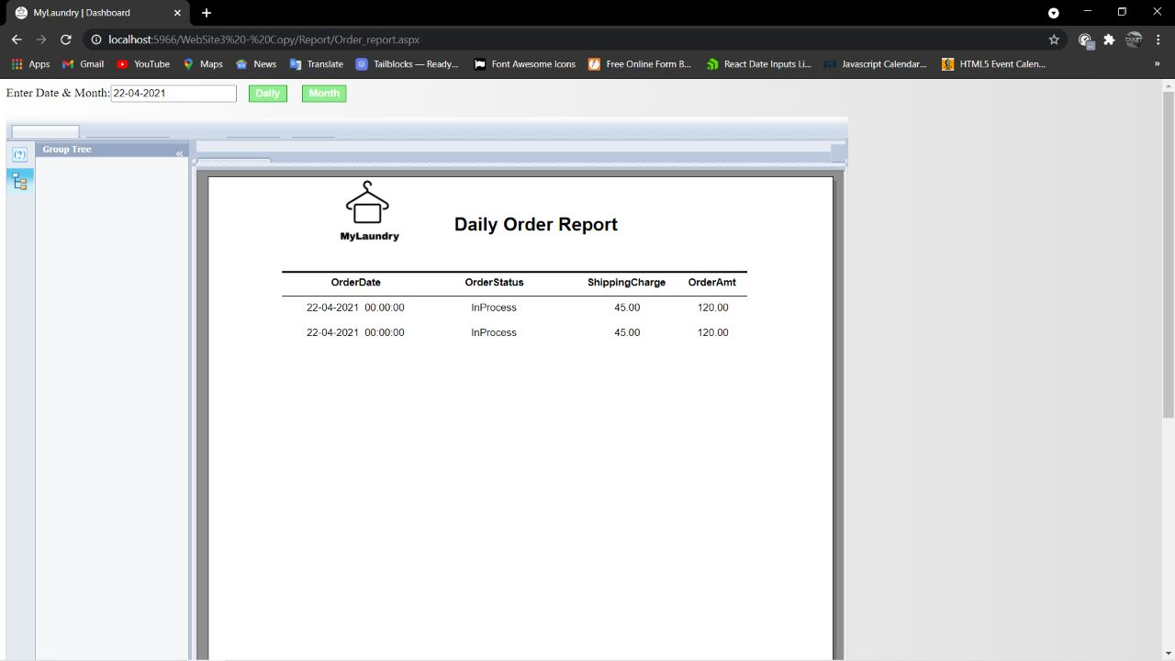

* **Monthly Order Report.**

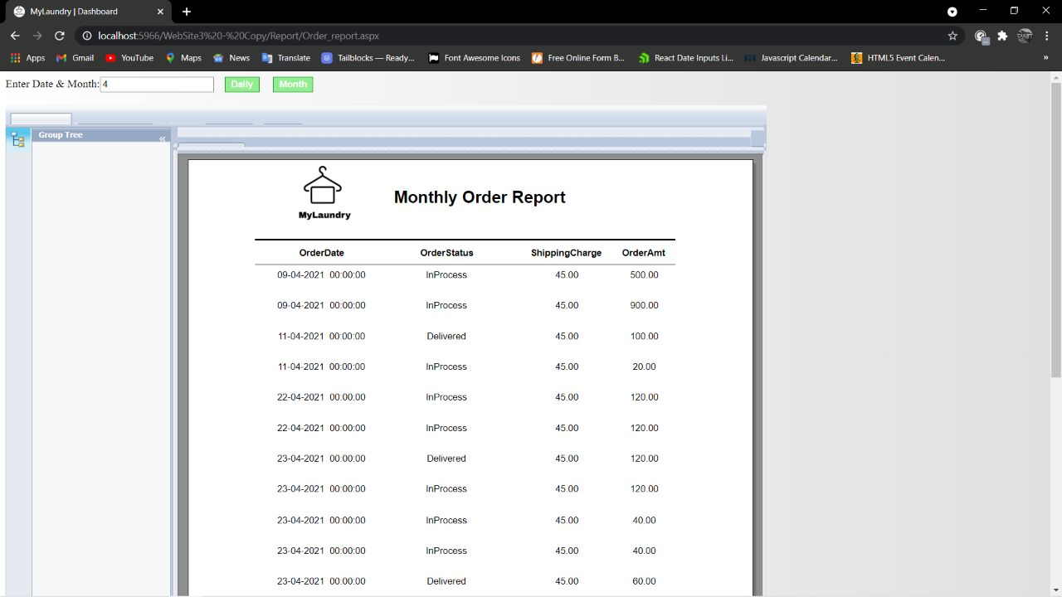

* **Daily Appointment Report.**

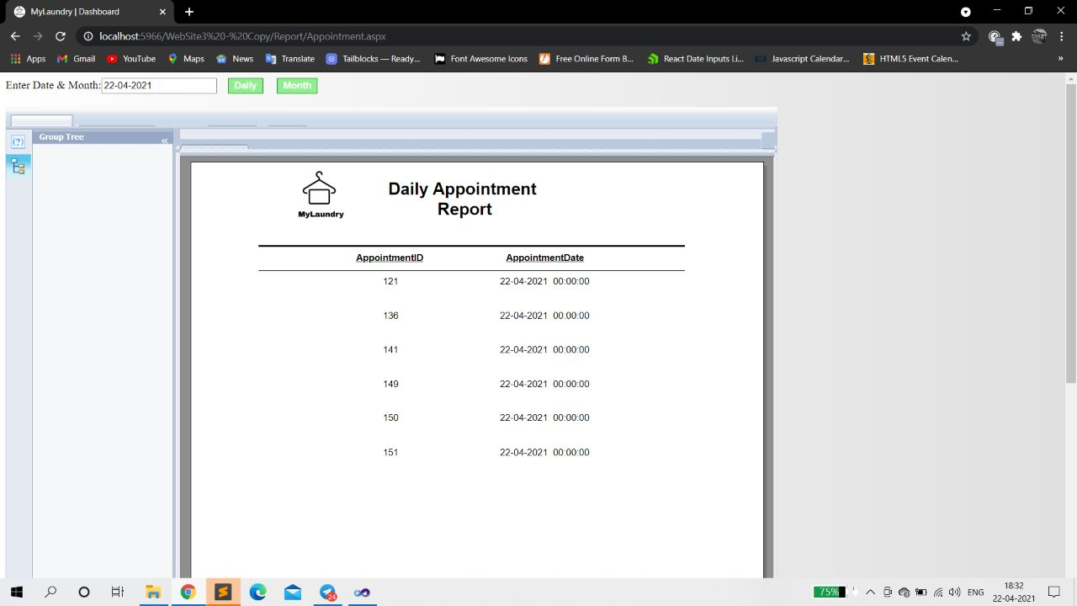

* **Monthly Appointment**

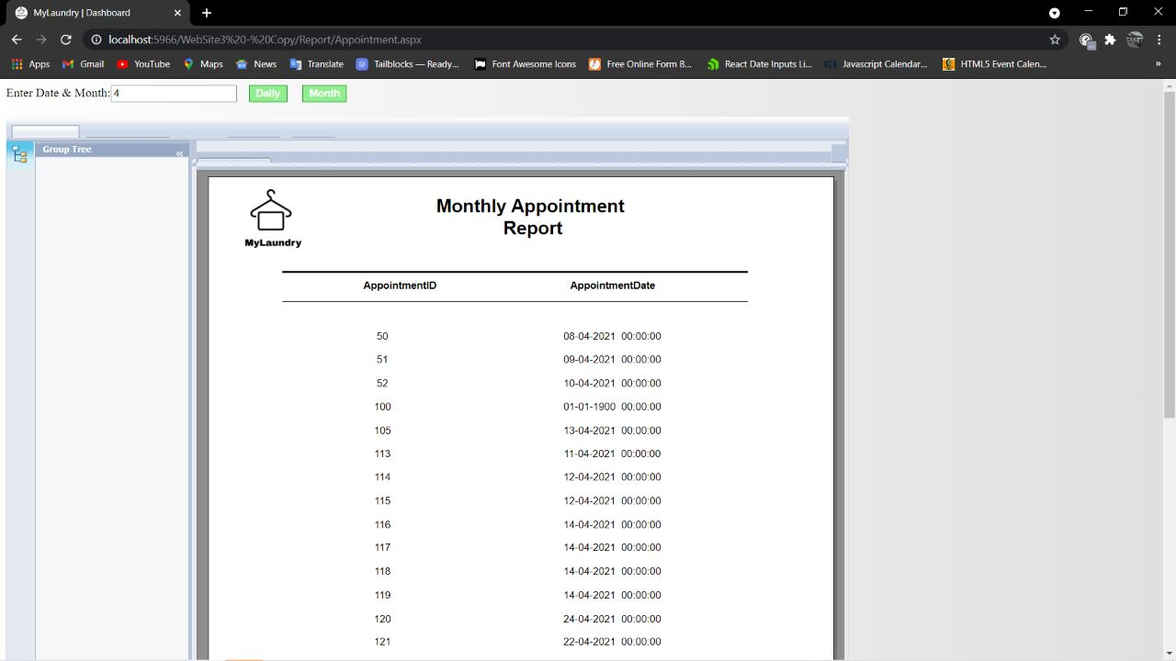

* **Area wise Customer Report**

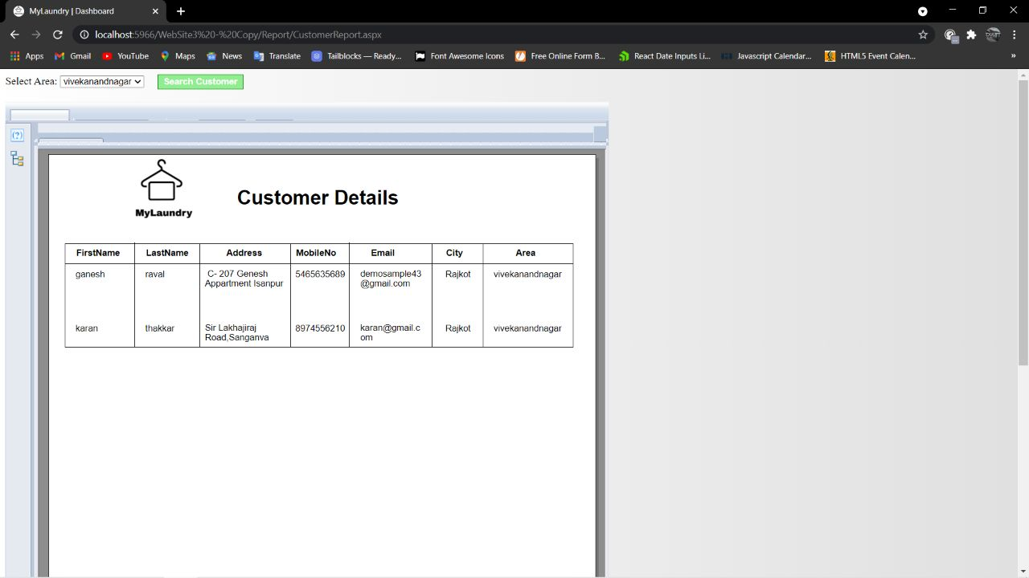

* **Pricelist Details Report**

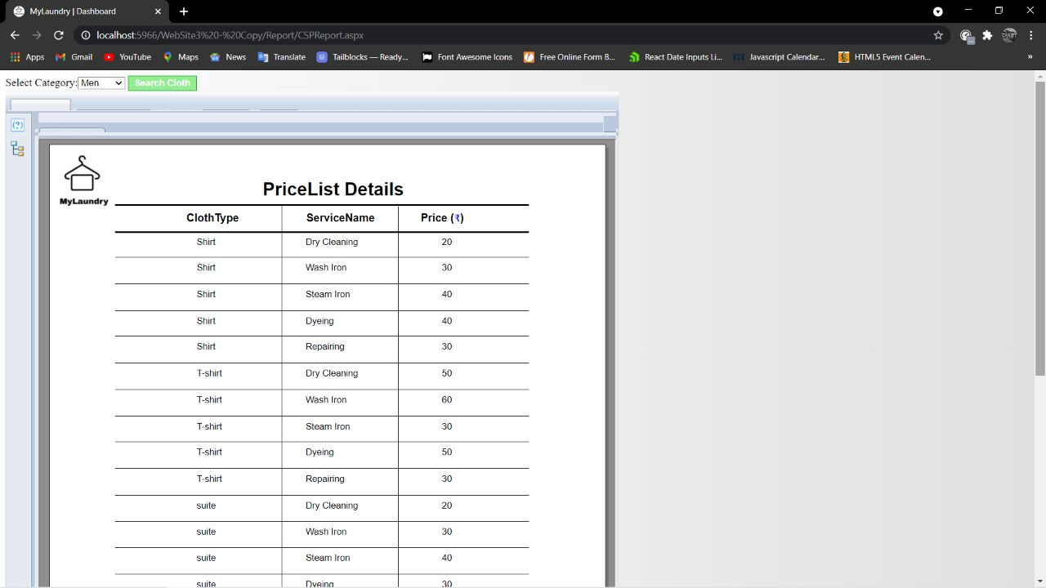

**Thank You**